Illogan School

Teaching, Learning and Assessment Policy

Introduction
At Illogan we believe that learning should be an enjoyable and rewarding experience. Through our teaching we equip children with the skills, knowledge and understanding necessary for the next stage of their education and their future lives.
Teaching is a cyclical process where the teachers’ knowledge of the individual pupils, how they learn and the progress they make is vital. Knowledge of pupils is used to inform planning, the success of which is then monitored, assessed and reviewed throughout the lesson. This informs the focus for subsequent teaching.

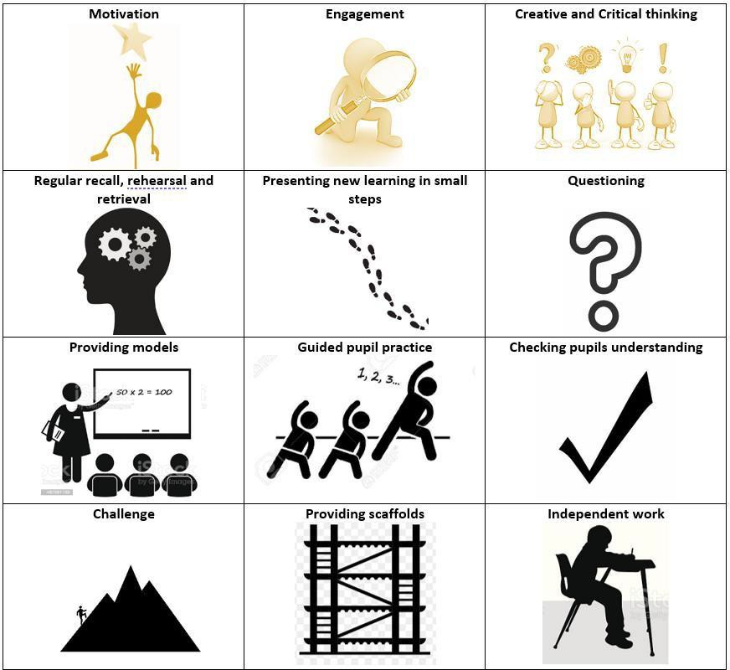
Core Principles

Quality First Teaching
Our key principles are:
- We explicitly build frequent opportunities for formative assessment into all lessons
- All teachers reflect on pupil progress within and at the end of every lesson, considering next steps for learning
- Opportunities for pupils to recall, revisit and retrieve key knowledge are embedded within our curriculum sequence. We use our Illogan Heartbeats to support this process, as specified below.
- Feedback (including marking) is used to help pupils improve their understanding
- We use strategies that minimise teacher workload but maximise pupil progress
- We use the Walk Thru materials and coaching to focus on the core principles

The basis of our teaching pedagogy is as follows:

Daily, weekly and monthly recall, rehearsal and retrieval using our school Heartbeats
Every half term all teachers will:
- Expose children to all the Heartbeats in each subject during the beginning of their project. Heart beats will be visible on slides in all subjects and be referenced every lesson.
- Heartbeats will be visible on displays in the classroom. They will be used to display relevant examples of learning and for retrieval practice.
- Heartbeats will also be shared and sent home to parents during the first week following a holiday.
- Each lesson will begin with three key questions: What is ‘Art/RE/Geography’? What is our current project? What have you learnt so far? Following this there will be an opportunity for retrieval practice. This may include: a quiz/peer retrieval/a mnemonic which is directly linked to the knowledge specified on our Heartbeats. There will be evidence of weekly rapid recall of heartbeat knowledge in History and Science (last lesson, last term, last year). There will be fortnightly evidence of heartbeat retrieval in RE.
- Use formative assessment opportunities to regularly assess the children’s retention of Heartbeat knowledge.
- In Art lessons, use smaller versions of the Heartbeats to identify where learning is linked and reflects the knowledge specified.

Presenting new learning in small steps
We understand that the working memory is limited and easily overloaded. Small amounts of new learning are presented and taught in a way that enables each point to be mastered before the next point is introduced. We reteach concepts where appropriate, before moving on.
Mastering concepts in maths
Linking new vocabulary to words already known

Providing models
Teachers routinely model expectations. This provides pupils with specific steps to solve such problems and thus reduces the cognitive load on their working memory. The ‘thinking aloud’ aspect of modelling is an essential part of our teaching practice. At Illogan, we incorporate the following strategies:
Success criteria/steps to success (constructed with the children)
Clear models available for children to use for guidance displayed (visualiser/working walls) Resources to support learning (practical resources as well as supportive prompts)
Creating a classroom climate where everyone is ‘learning’ and makes mistakes – marvellous mistakes!

Ask Questions
We use questions to provide pupils with an opportunity to practice and to allow the teacher to determine how well material has been learned. We have established a range of strategies which involve all pupils in question responses these could include:
ABC questioning
Cold calling
Talk partners – tell your partner the answer Recording answers on whiteboards
Hands up – e.g. raise your hands if you agree with the answer that someone else has given Choral responses

Checking pupils’ understanding
We frequently check students to see what they have understood. This enables pupils to think more deeply, making connections between different ideas and concept and deepening their understanding. In addition teachers use the information gathered to identify and address misconceptions or gaps in learning. We check understanding by: Prompting pupils whether they agree/disagree with other students answers
Providing false examples to deepen thinking
Encouraging pupils to summarise the main idea in one or two sentences Asking pupils to ‘think aloud’ whilst they work or answer a questions Asking pupils to explain or defend their position to others.
Consciously supporting children to create their own ‘schemas’ – connect new concepts to existing ones explicitly (e.g. vocabulary acquisition).
Using a mastery approach, whereby pupils master small steps before moving on.

Guide pupil practice
This involves pupils practicing applying or elaborating the learning from the small steps with the teacher asking questions, checking understanding, and checking for misconceptions. It is an important step before independent practice.
We do this by;
Asking pupils to summarise the learning up until that point
Asking pupils to explain the learning to a partner

Challenge
Learning expects pupils to think, providing opportunities to build on prior knowledge, grapple with new concepts or new approaches and enables pupils to experience the joy of working hard to achieve something new. It should be challenging enough to motivate but not so hard that it is inaccessible.

Providing scaffolds
Scaffolds provide pupils with temporary support to help them learn new concepts, in time the scaffolding can be
removed. Such ‘scaffolds’ include:
Checklists, toolkits, word banks or cue cards Modelled, completed examples of tasks
Teachers ‘thinking aloud’ to show and model thought processes (e.g. modelling using a checklist to evaluate their own work).
Teachers anticipating potential errors and warning pupils of these e.g. teach the teacher

Independent practice
Following extensive modelling and scaffolding, pupils are given opportunities to then apply this independently. This independent practice is essential in order to become fluent, automatic and to be able to apply the skill or knowledge. Independent practice includes:
Practising concepts repetitively, possibly in different subject areas Reteaching material when necessary
Mixed ability pairings where pupils are required to explain answers to their partner Collaborative learning

Long Term Planning
Subject leaders have developed overviews for each National Curriculum subject which further detail the content of the school’s Long Term Plan. Heartbeat progression documents identify key learning for each year group across the school and demonstrate the sequence and progression of learning in history, geography, RE, art and science. Teacher subject knowledge and the expertise of leaders is vital, we have therefore chosen to support the planning and implementation of some areas of the curriculum with carefully selected commercial schemes, details of these can be found on the subject website pages.

Medium Term Planning

Subject leaders create medium term plans with supporting documents which provide teachers with a logically sequenced unit of work, identify essential prior learning and expected outcomes.
This is sequenced as follows:
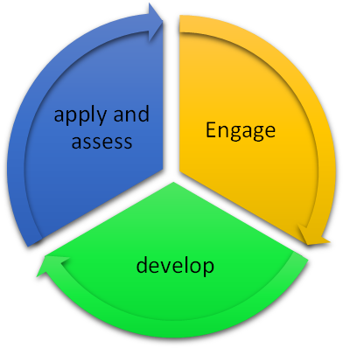
Engage – Pupil’s curiosity is stimulated through a ‘hook’ or memorable experience. Teachers use this stage to assess pupils prior learning, identify and address any gaps before moving on.
Develop – Learning opportunities delve more deeply, explore concepts and acquire new knowledge. During this stage pupils will build on previously acquired skills and knowledge and make links between subjects. They will communicate their learning in a variety of ways.
Apply and Assess – Towards the end of a unit pupils will have the opportunity to consolidate their learning and apply this to a new context. Teachers will use this opportunity to assess understanding against the agreed check points.

Daily Practice
Class teachers have responsibility for planning the lessons they teach; this could be in the form of slides. Slides should include precise learning intention with a well-matched task, key vocabulary.
The design of the lessons planned should include the key principles outlined above although some subjects may have a particular lesson structure e.g. reading, writing and maths. Details of these can be found in the relevant policies.
Pupil’s books should be a record of learning experiences, providing an opportunity to evidence guided and independent practice. In core subjects (including science and RE) the learning intention of every lesson should be recorded in pupil’s books alongside a record of the task completed (this could be photographs, diagrams etc as appropriate). The tasks selected by the teacher for independent practice must match the learning intention of the lesson, giving pupils an opportunity to think more deeply and apply their learning. We have high expectations of the pupils and encourage them to have high expectations of themselves in terms of effort, presentation and quality of content across all curriculum subjects.
Learning Environment
The environment that both pupils and staff work in is important both culturally and physically. We recognise the importance of pupils feeling safe, happy and supported, enabling them to take risks in their learning. The culture within our classrooms is inclusive, purposeful and engaging with opportunities made to reinforce our learning habits. Research demonstrates the importance of children feeling that their classroom is ‘theirs’ (see appendix for learning environment checklist). Pupils’ work will be displayed on the class board within the Heart space to celebrate achievements and motivate others; teachers will ensure all children have the opportunity to see their work celebrated over time. Further details regarding our learning environment expectations can be found in appendix 1.

Role of Parents/Guardians
We believe that parents have a fundamental role in helping children to learn. We do all we can to inform parents about what and how their children are learning by:
- Holding open afternoons and parents’ evenings to discuss how children are progressing
- Holding ‘Meet the Teacher’ sessions early in the Autumn term
- Sending home an annual report to parents
- Explaining to parents how they can support children to learn at home

Monitoring and Evaluation
Staff development needs are continually reviewed as part of the monitoring timetable, information gathered feeds into the school development plan and appraisal. This Teaching and Learning Policy has been formulated for staff to evaluate the quality of teaching and learning in their classroom and across the school.
In order to provide a clear picture of the quality and consistency of practice across the school, when evaluating teaching and learning in school, it will be monitored and evaluated through:
- Classroom observation
- Sampling pupils’ work
- Sharing pupils’ work throughout school and discussing its quality
- Moderation of pupils’ work internally and across the MAT schools
- Discussion with pupils

The classroom learning environment is key in supporting children to develop independence, they need to be able to access the support and resources they need easily. Developing specific areas of the classroom and labeling draws will be really helpful here.
Children need to feel a sense of belonging within the classroom, and should take responsibility for keeping things tidy. Classrooms should be well organised and clutter free, allowing easy movement around the room.
Displays have two key functions:
- To support learning through provision of learning prompts and models
- To celebrate success and encourage others to achieve
When setting up your classroom please ensure you have the following:

Requirement | In place?
All displays should be securely attached with no ripped boarders/ posters. Muted backgrounds with pastel borders are preferable. Writing border= yellow, reading = orange, maths = blue, science = green, topic (RE/Geo/His) = pink, PSHE = purple
Please keep things blue tacked to the windows or walls to a minimum.
Ensure surfaces are clear, no clutter
If you have a whiteboard, do not clutter this
All trays to be labelled in Sassoon font
Cover up door numbers with a reading poster and class name
Welcome to our class poster– different languages
Safeguarding poster
Class Expectations/rules
Visual timetable for the whole class (this could just be the plan for the day written on the board)
Include the Illogan Hearts and affirmations with the squad tokens nearby
Jigsaw charter/Paws and class Jiggy at the front of the classroom
Zone of Regulation display that is interactive and developed with the children

Requirement | In place?
Reading (can be shared with English boards)
(Use VIPER snakes)
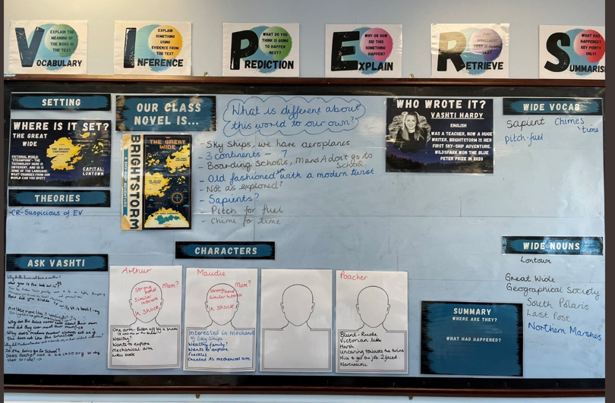

English
Word hoard - could be display/ treasure chest etc if there is space
What we are reading poster on classroom door and exterior door which is regularly updated and a teacher recommendation
Maths learning wall
Place value grid
Relevant vocab
Manipulatives/visual representations (concrete, visual, abstract)
Examples of key methods, including the vocabulary relating to each method
Place value grid
Key questions relevant to current topic
Resources underneath for children access
Reasoning sentence stems/sentence stems for current unit of work
Times tables section (from Year 2)
Number line
Curriculum – this should reflect the current topic and include:
A title
Key vocabulary
Examples of pupil’s work
You may also include questions and answers, evidence of home learning etc.
History Timeline with relevant dates that build each year underneath the Topic board
EYFS and KS1 - RWI speed sounds poster
Laminated heartbeats are visible on topic displays – these reflect the current topic. Teachers will annotate laminated hearts with a cue to support retrieval e.g. key vocab/image. These can be displayed next to relevant pupil work.

Accessible information required in case of supply (stored discreetly, inside of cupboard door?)
Medical information, Asthma register, Timetable, Dismissal arrangements, SEN learning plans, behaviour arrangements/PSPs/Pupil passports

