Date Agreed:  July 2022 | Headteacher:  Miss Lucy Wandless
Date for Review:  September 2023 | PE Coordinator:  Miss Eloise Rapsey
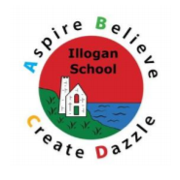
Illogan School PE Policy

Introduction, Ethos and Objectives:
Introduction:
Physical activity contributes to the development of pupil’s ‘physical literacy and provides them with the knowledge, skills and motivation necessary to equip them for a healthy lifestyle and lifelong participation in physical activity and sport.’ (AfPE, 2015)
As a staff, we have identified the key factors why Physical Education (PE) and activity forms an important part of our planning and provision.
These key factors include the importance (and resulting impact) of:
- regular exercise on positive behaviour and concentration levels;
- learning within physical activity which can be key in the development of agility, balance and coordination;
- experiencing leadership, teamwork, listening and communication tasks;
- enabling all children to take part in physical activity regardless of race, culture, physical and learning disabilities;
- providing opportunities to challenge and support children who are talented in particular areas of PE.
This policy recognises how PE is an integral part of the process of education and plays an important role in the total development of each pupil. PE, along with sport and physical activity, can bring about whole school improvement through impacting on attendance, behaviour and pupil attainment. The school believes that physical education, experienced in a safe and supportive environment, is vital and unique in its contribution to a pupil’s physical and emotional development and health.
The physical education curriculum at Illogan aims to provide for pupils’ increasing self- confidence through an ability to manage themselves successfully in a variety of situations. A balance of individual, team, co-operative and competitive activities aims to cater for individual pupil’s needs and abilities. The REAL PE and REAL GYM schemes of work include progressive learning objectives and outcomes which, combined with varied and flexible teaching styles, endeavour to provide appropriate, stimulating, challenging and enjoyable learning situations for all pupils.
The schemes aim to promote an understanding of the many benefits of exercise, through a balanced range of relevant activities. Physical education is considered as a vehicle to facilitate access to cross-curricular themes, skills and dimensions, rather than a subject concerned exclusively with the acquisition of motor skills and techniques.
Ethos:
At Illogan, we believe in using PE as a vehicle for developing children holistically. We pride ourselves on providing a high-quality physical education curriculum that inspires all pupils to succeed and excel in competitive sport and other physically demanding activities. We consider PE a means for all children to be able to develop to their full potential – academically, socially, emotionally, physically, morally & spiritually, enabling each child to grow in confidence and able to engage and contribute within the wider community. PE lessons provide opportunities for all pupils to become physically confident in a way that supports their health and fitness alongside developing their mental wellbeing and fundamental learning skills such as problem solving and resilience. In PE lessons, we encourage and support children to Aspire, Believe, Create and Dazzle regardless of their physical starting point or background.

Objectives:
The objectives of teaching PE in our school are:
- to enable children to develop and explore physical skills with increasing control and coordination;
- to encourage children to work and play with others in a range of group situations;
- to develop the way children perform skills, and apply rules and conventions, for different activities;
- to show children how to improve the quality and control of their performance;
- to teach children to recognise and describe how their bodies change and feel during extended periods of exercise;
- to develop the children’s enjoyment of physical activity through creativity and imagination;
- to develop an understanding in children of how to succeed in a range of physical activities, and how to evaluate their own success;
- to provide the minimum of 2hrs physical activity a week through, break times/lunchtimes, formal P.E lessons and to provide opportunities for further activities/signpost children to clubs - both extra-curricular and in the those present in the wider community.
We will:
- provide a safe, secure learning environment;
- offer opportunities for learning that allows opportunities to develop self-esteem, independence and knowledge;
- help children to foster a life-long love of learning;
- promote equal opportunities for all children regardless of their starting point;
- promote positive and respectful relationships and a respect for self, others and members of the wider community;
- ensure pupils achieve their potential through a variety of active independent learning, small group work, whole class sessions and constructive feedback from themselves, peers or teaching staff;
- provide a quality education in an inclusive environment;
- support and engage parents, and members of the wider community to become healthier and to promote healthy lifestyles to the young people in our care.
Outcomes:
The intended outcomes that we deem to be desirable from the PE programme offered at Illogan include:
- Skill acquisition
- Skill application
- Movement appreciation
- Movement observation
- Knowledge
- Understanding
- Health/fitness principles
- Awareness of safety
- Competition
- Rules (how to officiate)
- Leadership
- Challenges
- Enjoyment
- Creativity
- Problem solving
- Self-control
- Tolerance
- Respect
- Honesty
- Improved self-esteem
- Responsibility
- Sense of achievement/wellbeing
- Communication skills
- Language terminology
- Improved social skills
- Recreation in society

Our Curriculum:
Early Years Foundation Stage:
Physical development involves providing opportunities for young children to be active and interactive; and to develop their co-ordination, control, and movement. Children must also be helped to understand the importance of physical activity, and to make healthy choices in relation to food. PE lessons in EYFS tend to have themes to encourage participation and enjoyment for all children.
Key Stage 1:
Pupils should develop fundamental movement skills, become increasingly competent and confident and access a broad range of opportunities to extend their agility, balance and coordination, individually and with others. They should be able to engage in competitive (both against self and against others) and co-operative physical activities, in a range of increasingly challenging situations.
Pupils should be taught to:
- master basic movements including running, jumping, throwing and catching, as well as developing balance, agility and co-ordination, and begin to apply these in a range of activities;
- participate in team games, developing simple tactics for attacking and defending;
- perform dance and gymnastics routines using simple movement patterns.
Key Stage 2:
Pupils should continue to apply and develop a broader range of skills, learning how to use them in different ways and to link them to make actions and sequences of movement. They should enjoy communicating, collaborating and competing against themselves and each other. They should develop an understanding of how to improve in different physical activities and sports and learn how to evaluate and recognise their own success and failure as well as the successes and failures of others.
Pupils should be taught to:
- use running, jumping, throwing and catching in isolation and in combination;
- play competitive games, modified where appropriate [for example, badminton, basketball, cricket, football, hockey, netball, rounders and tennis], and apply basic principles suitable for attacking and defending;
- develop flexibility, strength, technique, control and balance (for example, through athletics and gymnastics);
- perform dances and gymnastics routines using a range of movement patterns;
- take part in outdoor and adventurous activity challenges both individually and within a team;
- compare their performances with previous ones and demonstrate improvement to achieve their personal best.
Swimming and Water Safety:
All schools must provide swimming instruction either in key stage 1 or key stage 2. However, we consider this vital considering our proximity to the ocean. Pupils at Illogan are taught to:
- swim competently, confidently and proficiently over a distance of at least 25 metres;
- use a range of strokes effectively (for example, front crawl, backstroke and breaststroke);
- perform safe self-rescue in different water-based situations.

Teaching and Learning:
Teaching and Learning:
Throughout the school, PE lessons are taught by the class teachers and trained PE coaches. PE lessons taught by a PE coach are aimed to support teachers with their professional development and teachers should take an active role in these sessions. At Illogan, we use a variety of teaching and learning styles to develop the children’s knowledge, skills and understanding of PE. In each lesson, children are given the opportunity to enhance their skills, explore and develop ideas, and evaluate their work. Both adults and competent children model set tasks and children should be encouraged to evaluate their own and others’ performance, suggesting appropriate improvements. Skills are often taught in isolation and then time is given to apply taught skills in game situations – providing opportunities to work independently and as part of a team. Children have access to a range of PE equipment and a fantastic online learning resource. This online learning platform has been shared with parents and participation is also encouraged in the home environment.
Inclusion and equal opportunities:
Equal opportunities
Activities should be carefully planned by the class teacher and be differentiated where appropriate for children with SEN and equally the more able and Gifted and Talented children. All resources/materials have been reviewed with equal opportunities in mind, e.g. race, gender, ethnicity. Learning experiences in PE will be available to every child, regardless of race, gender, class or ability. Pupils will be encouraged to value social and cultural diversity through PE experiences. They will participate in a variety of experiences in a positive and constructive role.

Inclusion
We recognise that in all classes, children have a wide range of ability, and so we seek to provide suitable learning opportunities for all children by matching the challenge of the task to the ability of the child. We achieve this in a variety of ways:
· setting tasks which are open-ended and can have a variety of responses;
· setting tasks of increasing difficulty;
· grouping children by ability and setting different tasks for each group;
· grouping children in mixed ability groups;
· providing resources of different complexity, depending on the ability of the child;
· using classroom assistants to support the work of individuals or groups of children.

The Role of the PE Coordinator:
The PE Co-ordinator is responsible for ensuring that practices improve the quality of education provided, meet the standards and aspirations of all pupils, and raise standards of achievement in school. They play a key role in supporting, guiding and motivating teachers and other adults of the subject. Their role also includes taking responsibility for the overall implementation and management of the ‘Physical Education Policy’ along with checking and maintaining the quality of the PE equipment and the teaching of PE across the school. The PE coordinator will champion their subject at all times and will ensure that the successes linked to PE are celebrated and a love for physical learning is cultivated at every opportunity. The PE Coordinator will also be responsible for organising fixtures within school, the Crofty MAT and wider community. The PE Coordinator will regularly liaise with outside agencies and local secondary schools to keep up-to-date with any extracurricular sports activities or clubs taking place.
Curriculum/Planning/Assessment:
We use the National Curriculum in England: Physical Education Programmes of Study, Statutory Framework for the Early Years Foundation Stage and REAL PE to plan and deliver enjoyable, engaging and effective PE lessons that develop children’s knowledge, skills and understanding. Planning is used as a working document, which can be adapted as the learning progresses.
Throughout KS2, children develop their swimming and water safety skills through blocks of swimming lessons (planned and delivered by trained swimming instructors). Additional lessons are provided in the Summer Term to those children in UKS2 who have not achieved the requirements outlined in the National Curriculum.
The PE curriculum is concerned with the learning and participation of ALL students. Teachers use their knowledge of individual children and on-going formative assessment to ensure that activities match the ability of the child. Similarly to other subjects, tasks are differentiated to meet individual needs and are planned to extend pupils’ learning. This differentiation is often a choice made by pupils in individual lessons providing them with greater control over their learning and ensuring that they progress at an appropriate pace whilst maintaining high levels of enjoyment.
Teachers should use formative assessment through observations during PE lessons. Children should be given clear learning objectives to promote opportunities for self- and peer-assessment within lessons. Teachers should ensure lessons are progressive, inclusive and differentiated to children’s’ individual needs. Teachers need to assess children and make a judgement using the following criteria:
- Working Below: children have been taught a skill but are unable to apply their understanding unless supported;
- Working At: children beginning to apply their understanding of a taught skill independently;
- Secure: consistently using a taught skill independently.
These judgements will be and collated on the REAL PE assessment framework thus providing consistency throughout the school and a means of monitoring progress both within and across individual year groups or key stages.

PE Curriculum Map 2023 - 2024
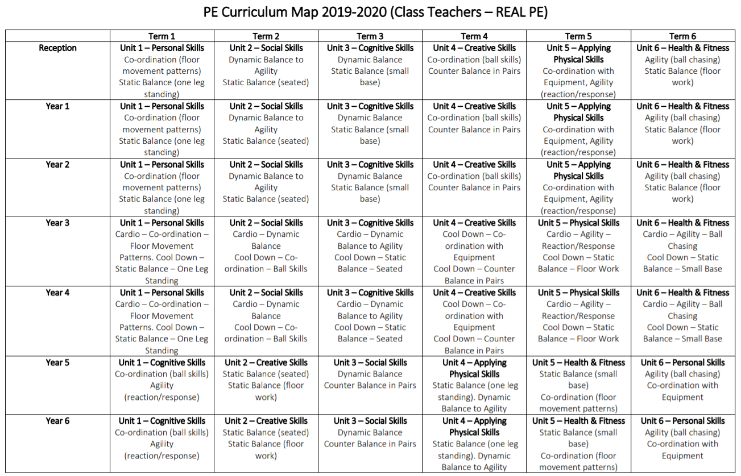

NB - Class teachers can alter the order of the units within a year group to suit their cohorts (ideally after discussion between the class teacher and PE coordinator).
PE Funding and Resources:
Sport Premium Funding:
Sport Premium Funding is money that is provided by the government to make additional and sustainable improvements to the quality of Physical Education, sport and physical activity within schools. The school has been in receipt of additional government funding specified as 'Sport Premium' since its introduction in September 2013. We have the opportunity to spend the Sport Premium as we feel will best support and benefit the pupils at our school. This extra funding must be spent on Physical Education, school sport and physical activity.
The ways in which we are using the Sport Premium to support our pupils is as follows:
- ensuring that all teachers have access to high quality CPD for increased skills, knowledge, understanding and confidence in gymnastics, dance and athletics;
- using REAL PE scheme of work to support and develop the consistent and effective teaching of PE throughout the school;
- purchasing REAL PE Legacy to continue developing PE and physical activity;
- purchasing new equipment to support the effective and safe teaching of the new scheme of work;
- providing transport to and from a wide range of competitive events;
- inviting and covering the costs of coaches from outside agencies to team-teach alongside existing staff to deliver a breadth of high-quality in school and after school activities for all ages (Cornwall Pirates, Chance 2 Shine Cricket, etc.).
Resources:
There is a wide range of resources to support the teaching of PE across the school. We keep most of our small equipment in the PE store, and this is accessible to children only under adult supervision. The hall contains a range of large apparatus, and we expect the children to help set up and put away this equipment as part of their work. By so doing, the children learn to handle equipment safely. The children use the school field for games and athletics activities, and the local swimming pool for swimming lessons. We also access facilities in our local secondary school through our school sports partnership, as well as expert coaches.
Real PE and Real Gym are web-based learning resources and therefore teaching staff will require access to a computer, the internet and will require a login and password for the online learning portal, Jasmine. The PE Coordinator will take responsibility for ensuring that staff are issued with these and will liaise directly with Create Development should any problems arise. Teaching staff will be expected to inform the PE Coordinator in a timely fashion should issues arise.

Health and Safety:
Safeguarding:
High standards of behaviour should be expected from pupils to ensure that a safe environment is established. Rules and routines should be embedded as quickly as possible and reiterated as often as necessary. If staff become aware of any signs of concern or abuse whilst teaching PE, they must report this to a Safeguarding Officer immediately and follow subsequent advice given.
Accident Procedure:
For school based activities staff should follow the guidelines in the Health and Safety Policy. For offsite activities, staff must familiarise themselves with the individual facility procedures. Risk assessments must be in place for any off site visits. For swimming sessions, all staff should familiarise themselves with pool procedures, e.g. the fire and drown alarms. They must know the location of rescue and survival equipment and have the ability to use emergency drill.
As a school we ensure the safety of all pupils and staff through the following codes of practice:
- Safe storage of all equipment – all equipment to be stored safely and tidily in its appropriate place after use, so easy access and availability are ready for the next group.
- Regular checking of equipment - equipment to be checked at the beginning and end of use. All unsafe, damaged or lost equipment to be reported to the PE Coordinator.
- Familiarisation of teaching locations - a knowledge of the environment in which learning is taking place - check areas for hazards before any activity takes place.
- Risk assessments – teaching staff conduct risk assessments for each area of PE prior to it being taught.
Our Procedure in the event of an accident during a PE lesson is as follows:
1. Remove child from further injury/danger. Isolate and stop the class if serious.
2. Administer first aid as appropriate. If the injury is minor, send the child to a first aider alongside a responsible child who can act as a helper.
3. If serious, send for a first aider for immediate attention. The first aider will assess the situation and call for further help if required.
4. Complete accident report, this can be found in the staff room.
5. Inform the member of staff who is in charge of Health and Safety of what happened and how.
Pupil Safety:
We encourage the children to consider their own safety and the safety of others at all times. We expect them to change for PE into the agreed clothing (shown below) for each activity area. The governing body expects the teachers to set a good example by wearing appropriate clothing when teaching PE. The policy of the governing body is that no potentially dangerous jewellery is to be worn for any physical activity.
PE Kit:
In the interest of health and safety, appropriate kit should be worn for P.E. activities. Acceptable kit is that which presents no risk of injury to the wearer or other participants.
Indoor Clothing:
- Appropriate clothing i.e. an Illogan School PE T-shirt (or plain white/red alternative) and shorts or jogging bottoms (no jeans),
- For particular lessons, children will be asked to take part in bare feet. However, they may also wear plimsolls or clean, plain sports trainers should they have them.

Outdoor Clothing:
- Sufficient, suitable clothing to be warm and comfortable in a games lesson (e.g. tracksuit bottoms and an appropriate top – no hoods or drawstring ties),
- Plain sports trainers.
Jewellery should be removed before the lesson. Long hair should be tied back.
The reluctance of some children to produce appropriate kit should be avoided if the child understands the necessity of changing for P.E. lessons and is familiar with the timetable. Staff will encourage and support all children to meet the requirements. Pupils who do not bring sufficient kit will be supplied with a spare kit and a phone call home will be made to remind parents/carers in future. All children are expected to participate in PE unless excused under medical grounds.
Children must change back into their school uniform at the end of the PE lesson and PE kits should remain in school for the duration of each half term, with the exception of children taking part in extra-curricular physical activities.

Monitoring and review of PE:
The work of the PE Coordinator involves supporting colleagues in their teaching, being informed about current developments in the subject, and providing a strategic lead and direction in the school. The PE Coordinator and the headteacher complete a VAP in which s/he evaluates the strengths and weaknesses in the subject, and indicates areas for further improvement.

