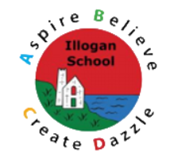
History Overview

EYFS | Year 1 | Year 2 | Year 3 | Year 4 | Year 5 | Year 6
Autumn |  |  |  |  |  |  |  | Autumn
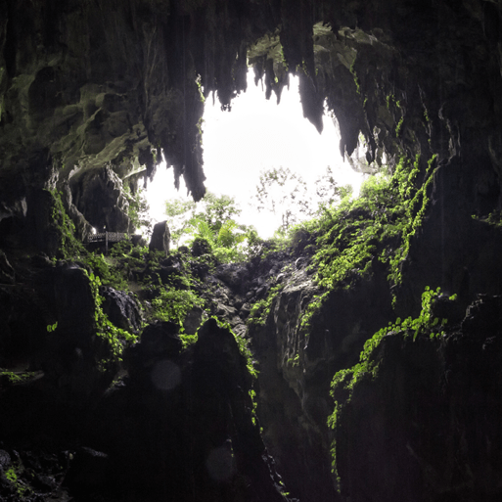  Let’s explore  This project teaches children about the environments that they share with others, including their homes, school and places in the local community. Children will explore the idea that a place can be significant because of its location, use buildings or landscape. Children will discuss how the local environment has changed over time using photographs and first-hand experiences. Children will learn that some people in history are significant because they did important things that changed the world or how we live. Children will begin to explore the idea that the way that people lived in the past is not the same as the way that we live now. There have been changes to schools, play activities, toys, food, transport and clothes. Children will explore the idea that living things change over time. This includes growth and decay. | 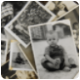  Childhood  In this history project, children develop their vocabulary of time, including before, a long time ago, yesterday, many years ago and present. The children are introduced to the concept of artefacts and explore a range of objects, interpreting what they tell us about childhood in the past. The children begin to compare artefacts from the past to the objects they use today.  Children develop their understanding that people grown and change over time and learn the stages of human development. They revisit learning from the Early Years about significant events, including birthdays and family celebrations, and are introduced to family trees.  They learn the word ‘decade’ and its meaning. They order decades chronologically and learn about significant events,  including important aspects of our monarch’s reign. Children use photographs as historical sources to compare everyday life and childhood in the 1950s to today. They also explore a significant event, the Queen’s coronation, and learn that this was the start of her reign. | Movers and Shakers  In this history project, children focus on significant people throughout history.  They are introduced to Dawson’s  model of significance, which helps them to decide if a  person is historically significant. They learn about a  significant person from the locality and evaluate their impact on the local area, the United Kingdom and the world.  The children are introduced to the vocabulary used to describe the work or actions of significant people, such as activists, artists, explorers, monarchs and scientists. They group significant people under these headings and then learn about their lives. The children are introduced to diamond ranking to sort the people studied from the most to the least significant, using their knowledge of each person.  Children revisit the concept of chronology and timelines. They study two significant people in depth, Neil Armstong and Christopher Columbus, and learn the story of their achievements in chronological order. They begin to learn how to compare their voyages of discovery, especially relating to changes in technology.  Children study the actions and achievements of significant activists. They are introduced to the concepts of fact and opinion as they explore the life of Emmeline Pankhurst and learn about racial segregation in the USA through the activism of Rosa Parks.  The children turn their understanding of significance to modern times, looking at significant people and events today and predicting their impact on the future. They also add to their knowledge of monuments and memorials from the Y1 geography project, Bright Lights, Big City, studying how memorials recognise people and achievements. | 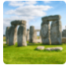  Through the Ages  In this history project, children learn new definitions that describe longer periods. They continue to learn about chronology by creating a timeline using these periods and are introduced to reading and ordering BC dates. Children are introduced to the concept of duration and calculate how many years each period lasted.  Children begin to carry out historical research using various artefacts and sources to answer historically valid questions and build up a picture of prehistoric life over the Stone Age, Bronze Age and Iron Age. They deepen their understanding of chronology by building detailed timelines of these periods.  Children develop their understanding of everyday life in each period, finding out about the people, places and changes over time that influenced human development. They learn about Stone Age settlements, tools, food and monuments and are introduced to new vocabulary, including hunter-gather, domestication, Neolithic revolution and Homo sapiens. Children are introduced to the terms ‘archaeology,’ ‘archaeologist’ and ‘excavation,’ learning about modern archaeological techniques and archaeological finds, including the settlement of Skara Brae and the discovery of the Cheddar Man. Children deepen their understanding of cause and effect, finding out what caused the end of the Stone Age, including the effects of life style changes and the arrival of new technologies.  Children learn about the arrival and influence of the Beaker folk and study the evidence that they left behind. They learn subject-specific vocabulary and concepts, including Beaker culture, metalworking, burial mounds, trade, ceremonies and afterlife. Children are taught how metal and trade influenced wealth and power and study the archaeological evidence from the burial of the Amebury Archer. They investigate the cause and effect of the end of the Bronze Age and learn the term ‘Bronze Age collapse.’  Children learn how ironworking came to Britain and the effect that this had on people’s lives. They learn the term Celt to describe the people of Britain and develop their understanding of concepts including conflict, farming, trade and wealth. Children learning about inventions and how new technology made everyday tasks easier and more efficient. They also study the archaeological evidence and decide what the artefacts tell them about craftsmanship, wealth and power in the Iron Age. Children learn about every day life in Iron Age hillforts and how iron weapons led to a warrior culture. Children find out about the end of the Iron Age and the Roman invasion and conquest.  Children study local archaeological evidence relating to the Stone Age, Bronze Age or Iron Age. At the end of the project, they compare and contrast the Stone Age and Iron Age, finding similarities and differences between the two periods and describing the changes that happened over time. | 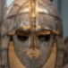  Invasion  Children will study the chronology of Britain between AD400 and 1066 using a timeline that shows the duration and overlap of different historical periods. They sequence significant dates and events in chronological order, deciding how a timeline helps them understand the sequence, and cause and effect of different events.  Children learn about the cause, consequence and impact of the invasion of the Anglo Saxons. They discover why the Anglo-Saxons left Scandinavia and created kingdoms in Britain, linking these ancient settlements with the country names that we use today. Children study primary and secondary sources, analysing artefacts from the Sutton Hoo ship burial to find evidence of the wealth, power and status of the buried person.  They learn about Christianity and paganism, learning how missionaries from Rome and Ireland brought Christianity back to Britain, following its decline after the Roman withdrawal. They explore the every lives of people in Anglo-Saxon Britain and study primary and secondary sources of evidence. Children are taught about the legacy of Anglo-Saxon life and which aspects still influence the world today.  The children complete a historical enquiry and learn about the Viking raids on the monastery of Lindisfarne, deepening their understanding of evidence and viewpoint as they study contemporary accounts. They investigate the conflict between the Vikings and the Anglo-Saxons and compare and contrast their everyday lives. Children use primary and secondary sources of evidence to learn about King Athelston and look at the continuity and change in Britain after his reign.  At the end of the project, children learn about the cause and effect of the Norman invasion, the final invasion of Britain and find out if there is any evidence of Anglo-Saxon or Viking life in their local area, using the knowledge and understanding gained throughout the project. | Dynamic Dynasties  In this history project, children learn about the history of ancient China. They revisit the term ‘civilisation’ and learn that ancient China was an advanced civilisation that grew without influence from the rest of the world. They make a timeline of the first dynasties of ancient Chine and learn how the civilisation began.  Children study the myth of the Yellow Emperor and the concept of dynasty. They study archaeological evidence from the lost city of Yin, which proved the existence of the Shang Dynasty. Children infer meaning from archaeological evidence and use their prior knowledge of civilisations to understand the role of belief, craftsmanship, hierarchy and power, everyday life and warfare during the Shang Dynasty. They encounter new vocabulary, including realm, ancestor, ritual, descendant, spirit and sacrifice. Children study the significance of the unique techniques and craftsmanship used to make bronze ritual objects and learn about the importance of jade carving and silk making.  Children study the structure of the Shang Dynasty society, recognising the familiar hierarchical structure showing the king at the top of the hierarch and peasants and slaves at the bottom. They discover that hierarchy and power influence everyday life and determined a person’s place in society. Children use primary and secondary sources to find out why the people of the Shang Dynasty were successful warriors, studying areas such as social structure, weapons, bronze, chariot technology, wealth and leadership to construct their arguments. They begin to compare conclusion, realising that people may interpret evidence in different ways.  Children use historical evidence to build a picture of a significant person, studying the tomb of Fu Hao. They ask historically valid questions about the warrior queen and use secondary sources to find the answers. Children answer the enquiry question ‘How did the actions of the last king lead to the downfall of the Shang Dynasty?’ and use the Records of the Grand Historian, considering if this is a good source of evidence. Children compare the Shang Dynasty to other Bronze Age civilisations, comparing and contrasting Egyptian, British and Chinese Bronze Age societies.  To conclude this project, children learn about life after  the Shang Dynasty, focusing on continuity and change  as they study the achievements and long-lasting impact of the Zhou, Qin and Han Dynasties. The children then look at Chinese culture today and identify the legacy of these ancient dynasties on China today. | 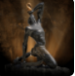  Maafa  In this history project, children learn abstract terms including rebellion, discrimination, colonisation, diaspora and emancipation. They learn about Africa as the ‘cradle of humankind,’ study a timeline of African history and discover the richness and diversity of ancient African kingdoms. Children work in research groups to find out about the Kingdom of Aksum, the Kingdom of Benin and the Mali Empire, studying aspects including rulers and government, natural resources and trade, homes, wealth, religion, culture and art.  Children learn about the significance of the discovery of the New World on African history and study Britain’s role in the development and growth of the slave trade over time, They learn about the development of the triangular slave trade and why this was a significant global event. They learn about the journeys, conditions on board slave ships and the human impact of life on a plantation. Children learn that the triangular slave trade created the African diaspora, which is the term for communities of black people living in different parts of the world due to the slave trade. They study a wide range of historical evidence to evaluate the human impact of the slave trade, including artefacts, diagrams and sources written by eyewitnesses.  Children develop their understanding of rebellion and divide and rule as they learn about life in enslavement. They think critically, weight the evidence and sift arguments as they study sources of evidence, understand the author’s viewpoints, why the sources were created and the contrasting representations of life in enslavement. Children learn the meaning of the terms resistance, revolt and refusal and how rebellion played a vital role in the abolition of slavery.  Children are taught how the profits of the slave trade affected life in Britain. They learn how money made from enslavement gave Britain wealth and power. They learn about the causes and consequences of the abolition of slavery. They revisit chronology, ordering a timeline of key events leading to the abolition of slavery and discover how religious groups, revolts, the work of abolitionists and economic considerations all affected the campaign. Children learn about life after abolition from different viewpoints.  They understand the concept of colonisation and look at the narrative and long and short-term causes and consequences of colonisation in the 19th and 20th centuries. Children learn about the lives of black people in Britain in the 20th century, understanding why black people came to live and work in Britain, the contributions they made to society and the difficulties they faced, They learn about the Race Relations Act in 1965, why it was passed and its impact on Britain. The children learn about the significance of inspirational black Britons over the last 500 years and write an account of their learning.
Summer |  |  |  |  |  |  |  | Summer 2
On the Beach  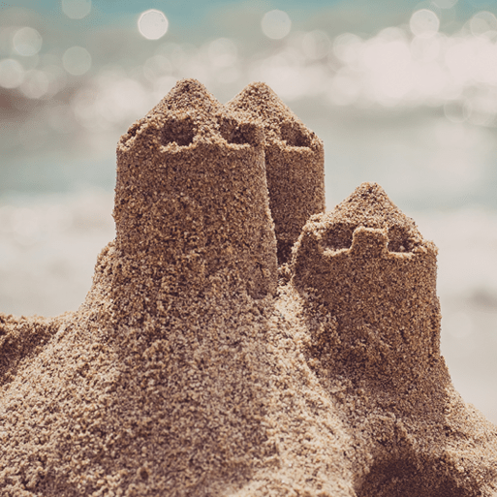  This project teaches children about the plants and animals that live at the seaside. It also explores holidays in the past and the importance of keeping safe in the Sun.  Children will learn that the way that people lived in the past is not the same as the way that we live now. There have been changes to schools, play activities, toys, food, transport and clothes. Children will be exposed to and employ words that help us to describe the passage of time include yesterday, last week, before and then. Children will start to offer explanations for why things happen, making use of vocabulary, such as, because, then and next. Children will begin to describe some similarities and differences between things in the past and the present. | School Days  This History project teaches children about their own school and locality, both today and in the past. They compare schooling in the Victorian era to their experiences today. The children learn about changes within living memory. Where appropriate, these should be used to reveal aspects of change in national life. The children learn about events beyond living memory that are significant nationally or globally. The children Learn about significant historical events, people and places in their own locality. The children Learn about the lives of significant individuals in the past who have contributed to national and international achievements. Some should be used to compare aspects of life in different periods. The children are introduced to historical concepts such as continuity and change, cause and consequence, similarity, difference and significance, and use them to make connections, draw contrasts, analyse trends, frame historically valid questions and create their own structured accounts, including written narratives and analyses. The children begin to understand the methods of historical enquiry, including how evidence is used rigorously to make historical claims, and discern how and why contrasting arguments and interpretations of the past have been constructed. | Magnificent Monarchs  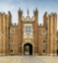  This history project teaches children about the English and British monarchy from AD 871 to the present day. Using timelines, information about royal palaces, portraits and other historical sources, they build up an understanding of the monarchs and then research six of the most significant sovereigns. Children will be exposed to Historical vocabulary such as; Historical periods; Timelines; Power and rule; Historical artefacts; Significant people - Alfred the Great, William the Conqueror; Henry VIII, Queen Victoria, Elizabeth II; Actions and impact; Historical models. The children will learn about changes within living memory. Where appropriate, these should be used to reveal aspects of change in national life. The children will learn about events beyond living memory that are significant nationally or globally. The children will learn about the lives of significant individuals in the past who have contributed to national and international achievements. Some should be used to compare aspects of life in different periods. The children will gain and deploy a historically grounded understanding of abstract terms such as ‘empire’, ‘civilisation’, ‘parliament’ and ‘peasantry’. The children will develop their understanding of historical concepts such as continuity and change, cause and consequence, similarity, difference and significance, and use them to make connections, draw contrasts, analyse trends, frame historically valid questions and create their own structured accounts, including written narratives and analyses. The children will develop their understanding of the methods of historical enquiry, including how evidence is used rigorously to make historical claims, and discern how and why contrasting arguments and interpretations of the past have been constructed. | Emperors and Empires  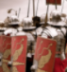  This history project teaches children about the history and structure of ancient Rome and the Roman Empire, including a detailed exploration of the Romanisation of Britain. Children will be exposed to Historical concepts such as Chronology; Everyday life in ancient Rome; Founding of Rome; Power and rule; Roman Empire; Significant emperors; Social hierarchy; Roman army; Roman invasion of Britain. The children will learn about the Roman Empire and its impact on Britain. Children will know and understand the history of these islands as a coherent, chronological narrative, from the earliest times to the present day: how people’s lives have shaped this nation and how Britain has influenced and been influenced by the wider world. Children will Understand historical concepts such as continuity and change, cause and consequence, similarity, difference and significance, and use them to make connections, draw contrasts, analyse trends, frame historically valid questions and create their own structured accounts, including written narratives and analyses. Children will understand the methods of historical enquiry, including how evidence is used rigorously to make historical claims, and discern how and why contrasting arguments and interpretations of the past have been constructed. | Ancient Civilisations  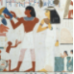  This project teaches children about the history of three of the world’s first ancient civilisations: ancient Sumer, ancient Egypt and the Indus Valley civilisation. Children will learn about the rise, life, achievements and eventual end of each civilisation. Children will learn that changes over time can happen rapidly or slowly and are affected by the desire for people to change, their beliefs, the availability of resources and technology, and social and economic circumstances. Children will learn about the characteristics of a civilisation include cities, government or leadership, forms of writing, numerical systems, calendars, architecture, art, religion, inventions and social structures. The form these characteristics take can be similar or contrasting across different civilisations. Children will learn the features and achievements of the earliest civilisations include cities, government, forms of writing, numerical systems, calendars, architecture, art, religion, inventions and social structures. Children will learn the profile of a leader can include their significant achievements, the events in which they played a part, the opinions of others about the person and the positive or negative consequences of their actions. Children will learn that the materials and decoration used to make an artefact can tell us about the skill of the craftworker and the status of the owner. The form can tell us how it was used. Children will learn that relevant historical information can be presented as written texts, tables, diagrams, captions and lists.- Children will develop their understanding that Key changes and events of historical periods can be placed on a timeline, such as the dates of changes in leadership, key battles and invasions, achievements, scientific developments and deaths. | Ground breaking Greeks  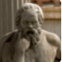  This history project teaches children about developments and changes over six periods of ancient Greek history, focusing on the city state of Athens in the Classical age, and exploring the lasting legacy of ancient Greece. Children will be explosed to historical terms including topic related vocabulary, which may include abstract nouns, such as peasantry, civilisation, treason, empire, rebellion and revolt. Children will learn that aspects of history that can be compared and contrasted include rulers and monarchs, everyday life, homes and work, technology and innovation. Children will learn about the achievements and influences of the ancient Greeks on the wider world include the English alphabet and language; democracy, including trial by jury; sport and the Olympic Games; the subjects of mathematics, science, philosophy, art, architecture and theatre. Children will learn about Ancient Greek everyday life, including culture, language, settlements, trade and belief systems could change during different periods due to invasion, natural disasters or changes in leadership. Children will learn that aspects of history are significant because they had an impact on a vast number of people, are remembered and commemorated or influence the way we live today. Children will learn that beliefs can prompt an individual to take action, such as to fight for change, fight wars, oppress or free individuals or groups of people, create temples and tombs or protest against injustice. Children will begin to understand that sources of historical information can have varying degrees of accuracy, depending on who wrote them, when they were written and the perspective of the writer. Children will learn that bias is the act of supporting or opposing a person or thing in an unfair way. A balanced argument is a response to a question or statement where you consider both viewpoints about a historical event or person. Children will begin to consider that continuity is the concept that aspects of life, such as rule and government, everyday life, settlements and beliefs, stay the same over time. Change is the concept that these aspects either progress and become bigger, better or more important, or decline and become smaller, worse or less important. | Britain at War  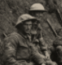  This history project teaches children about the causes, events and consequences of the First and Second World Wars, the influence of new inventions on warfare, how life in Great Britain was affected and the legacy of the wars in the post-war period. Children will learn that timelines demonstrate the chronology and links between key civilisations, events and significant inventions in world history. Children will learn that significant people, events, discoveries or inventions can affect many people over time. Children will develop their awareness that questions can be used to evaluate the usefulness of a historical source. Children will learn that common aspects of history, such as leadership, belief, lifestyle and significant events, are features of different historical time periods. Many of these threads have features in common, such as the invasion of a country by a leader and an army, but may also have differences, such as the success of an invasion. Children will develop their awareness that leaders and monarchs have changed the course of history in a variety of ways, including invading other countries; oppressing groups of people; advocating democracy; inspiring innovation or introducing new religious or political ideologies. Children will learn the consequences of resistance, refusal and rebellion against leaders or hierarchies are far reaching and can include war, conflict, oppression, change and improvements in people's lives. Children will learn that achievement or discovery may be significant because it affects the lives of other people or the natural world; moves human understanding forward; rights wrongs and injustices or celebrates the highest attainments of humans. Children will learn that causes of significant events can be long-term and revolve around set ideologies, institutions, oppression and living conditions or short-term, revolving around the immediate motivations and actions of individuals or groups of people. Children will learn that war, oppression, conflict and rebellion can cause damage to buildings and property; kill, injure and oppress people or change people's beliefs, ways of life and identity. Children will develop their awareness that different types of bias include political, cultural or racial. Children will learn that sources of historical information should be read critically to prove or disprove a historically valid idea.

