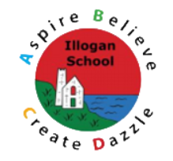
Geography Overview

EYFS | Year 1 | Year 2 | Year 3 | Year 4 | Year 5 | Year 6
Autumn
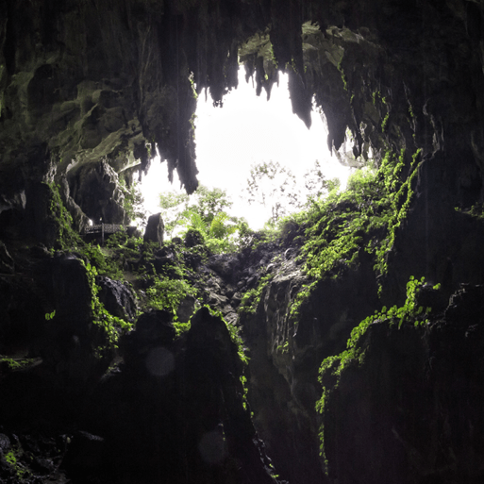  Let’s Explore  I can describe my immediate environment (including human features) using maps I have drawn to show what is important to me.  I know that we live on a planet called Earth and that we live in a country within the United Kingdom called England.  I can identify where object are in my environment  I can .. | 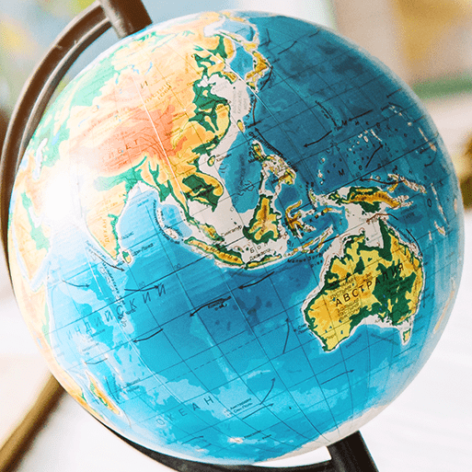  Our Wonderful World  I can draw picture maps with labels to show human and physical features.  I can describe the location of a feature and give directions using my map and appropriate vocabulary.  I can name the seven continents of the world and the five oceans – locating them on a map.  I know what the equator is and can identify hot and cold areas of the world on a map or globe.  I can name and locate on a map the countries which make up the United Kingdom and the capital cities.  I know that Illogan is a settlement and can name some key features – identifying these on a map and arial map. | 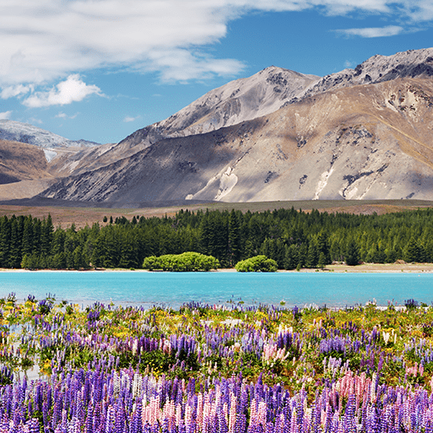  Let’s Explore our World  I can name and locate on a map the 4 countries of the UK, their capital cities and surrounding seas. I can describe some characteristics within each country eg rivers, mountains and cities.  I can ask geographical questions and collect data through fieldwork to answer questions and suggest ways to improve the environment.  I can name and locate the 7 continents and 5 oceans of the world, using my understanding of the equator to identify hot, cold and temperate areas (including naming some countries within those areas.)  I can identify similarities and differences between Somalia and England. | 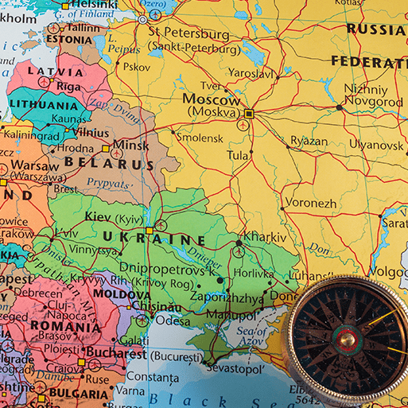  One Planet, Our World  I can use my geographical knowledge of maps, 4 figure grid references and the 8 points of the compass to locate places and features – making comparisons.  I understand the four layers of the Earth, and how the Earth’s crust is made of plates.  I can use my understanding of longitude and latitude to help identify the location of the Earth’s major climate zones.  I can name and locate some major countries and cities in Europe.  I can identify features of a settlement and offer reasons for their location.  I can name and locate some major counties and cities in the UK.  I know what carbon footprint means and can explain some ways to reduce this to protect the environment.  I understand the impact of extreme weather on people and the environment. | 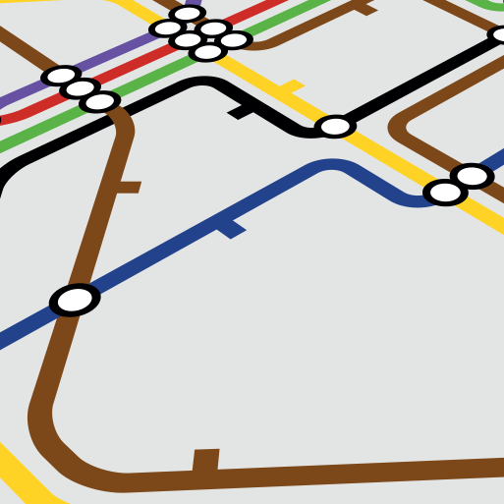  Interconnected World  Use the eight points of a compass, four and six-figure grid references, symbols and a key to locate and plot geographical places and features on a map.  Locate the world’s countries, using maps to focus on North and South America, concentrating on their environmental regions, key physical and human characteristics, countries, and major cities.  Name and locate counties and cities of the United Kingdom, geographical regions and their identifying human and physical characteristics, key topographical features (including hills, mountains, coasts and rivers), and land-use patterns; and understand how some of these aspects have changed over time. | 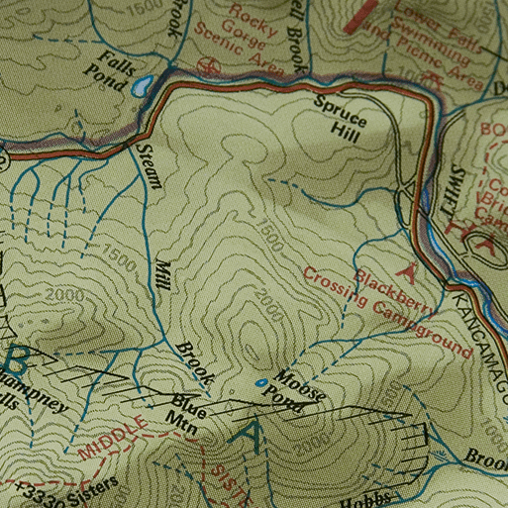  Investigating our World  I can use the eight points of a compass, four and six-figure grid references, symbols and key (including the use of Ordnance Survey maps).  I can explain the different time zones around the world.  I can name and locate the world’s biomes, vegetation belts and biomes and explain their common characteristics.  I can name, locate and describe major world cities, drawing comparisons between the continents.  I understand the environmental impact of mass production and can identify ways of reducing this.  I can describe the location of cities and key features within the UK, explaining how they are interconnected by transport networks.  I can identify and classify a settlement using population, amenities and significance. | 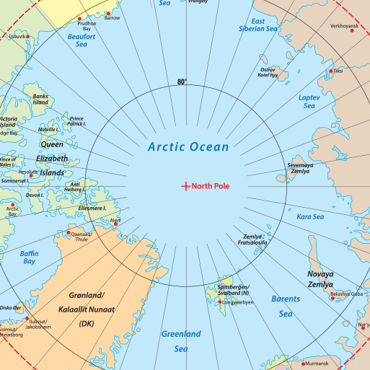  Our Changing World  I can recall and use my knowledge of features of Earth, time zones and lines of latitude and longitude to pinpoint places on a map.  I can use map scales, grid references, contour lines and map symbols to understand the geography of an area.  I understand some of the causes of global warming and climate change and have considered how these changes affect biomes. I can identify the effects of climate change and extreme weather on people. I know that trade occurs worldwide and can give examples of countries whose manufactured goods, foods or natural resources are exported across the globe. I know that natural resources need to be managed and the importance of sustainability.  I can use fieldwork to collect data and use my findings to suggest positive changes. I know about different patterns of human settlements and use primary data to analyse and describe settlement patterns in the local area.

Spring
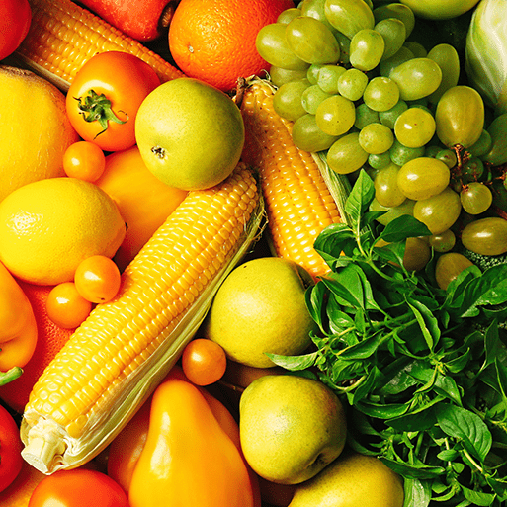  Ready, Steady Grow  I know that our food comes from farms and can give an example of what is farmed locally.  I can create a map to show a journey (real or imagined). | 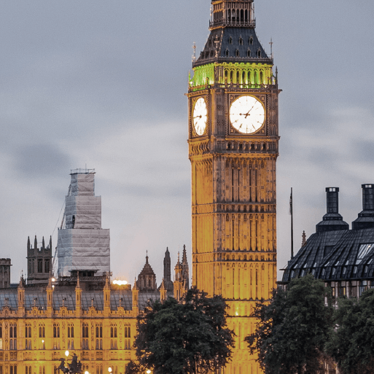  Bright Lights, Big City  I know the four countries of the UK, their position, capital cities.  I know the difference between human and physical features and can list examples of each including those that are common in the UK and locally.  I can describe seasonal weather patterns and make observations of the daily weather.  I understand what a settlement is and can use London as an example to describe features and landmarks.  I can use positional and directional language to give directions.  I can compare settlements in terms of climate, transport, size and location.  I can apply my knowledge and understanding of London to create a guide including information on transport, climate, location of landmarks. | 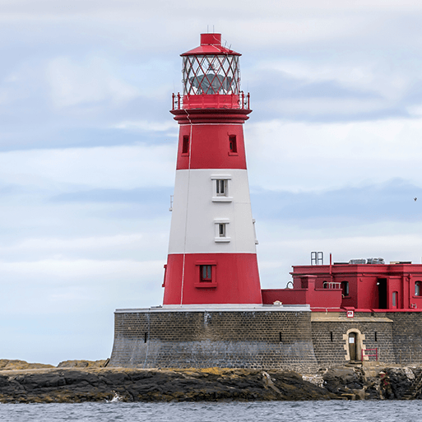  Coastline  I can name the seas that surround the UK and identify them on a map using cardinal compass points.  I can identify human and physical features of the coast.  I can draw or read a range of simple maps that use symbols and a key, using the information to answer questions.  I can describe how an environment has or might change over time.  I can gather land use information from maps and a fieldwork visit to draw links to tourism. | 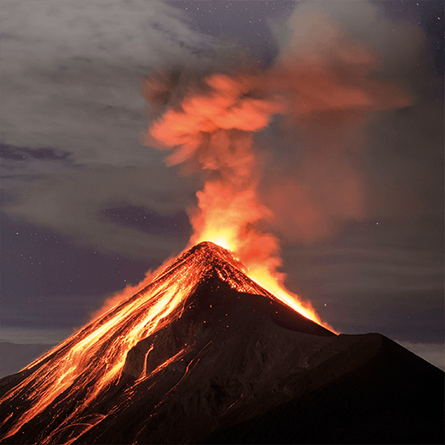  Rocks, Relics and Rumbles  I can describe the layers of the Earth.  I know that the Earth’s crust is made of plates and these have moved over time.  I know that volcanoes occur on plate boundaries and can explain why.  I can describe the parts of a volcano.  I can describe how the eruption of Kīlauea, Hawaii changed the landscape.  I know that earthquakes are caused by the movement of the Earth’s plates.  I can describe the short and long term effects of the 2016 Earthquake in Italy. | 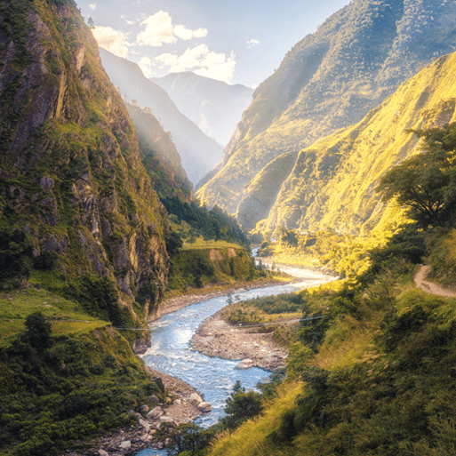  Misty Mountain, Winding River  I can use 4 figure grid references to describe the location of rivers and explain their significance for settlement, power, trade and land use.  I understand the 3 stages of a river.  I can describe the processes of erosion, transportation and deposition.  I know what a mountain is and can describe the different ways they are formed.  I can name and locate mountains and rivers within the UK, and worldwide.  I can describe the stages of the water cycle using appropriate vocabulary and diagrams.  I can describe altitudinal zonation on mountains and how these impacts living things. | 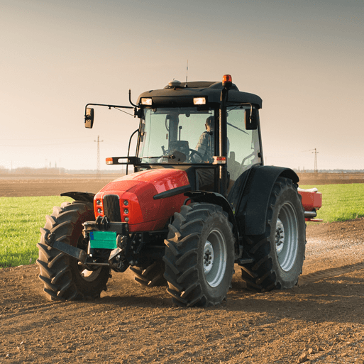  Sow, Grow and Farm  Describe in detail the different types of agricultural land use in the UK and locally.  Using topographical information gathered from a range of sources including OS maps, explain what the local area land use is.  Use knowledge of how climate, soil fertility, drainage and infrastructure impact agriculture.  Identify features of farming in Cornwall. | 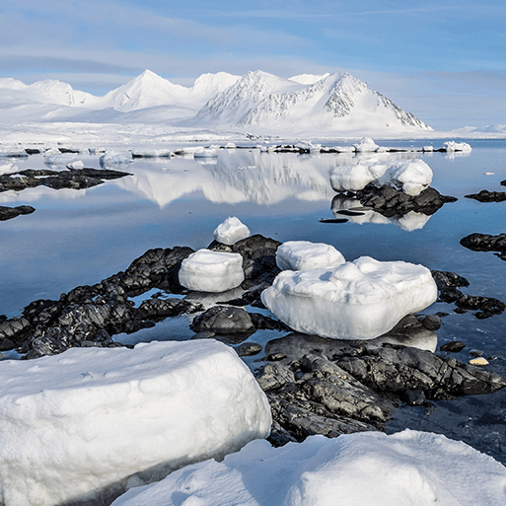  Frozen Kingdoms  I can draw together a range of geographical information to explain the key features of the polar reasons, the differences to other areas of the globe and the reasons for this.  I can explain how humans in the polar regions live and use the natural resources available there and the impact this has on the environment.  I can describe the impact of human activities on the climate.  I can describe and compare the range of biomes on Earth.
Summer
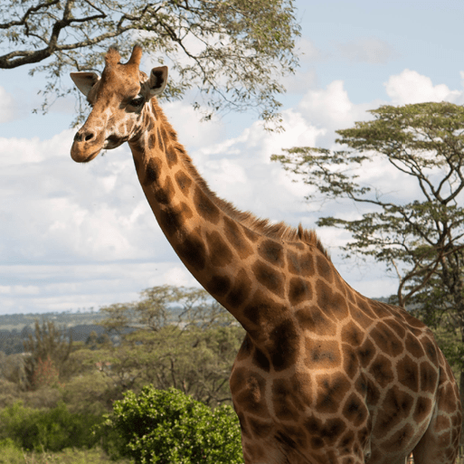  Animal Safari  I can name a range of non-native animals.  I can compare pets and wild animals.  I understand that animals grow and live in different parts of the world.  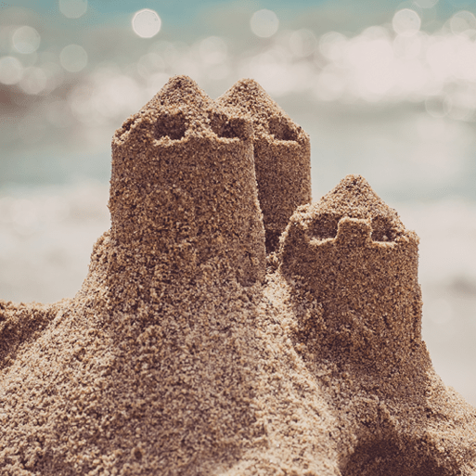  I can compare the habitats of certain animals (penguins and lions).  On the Beach  I can explain what a coast is.  I can identify land and water on a map.  I can recall items you may find on a beach. | 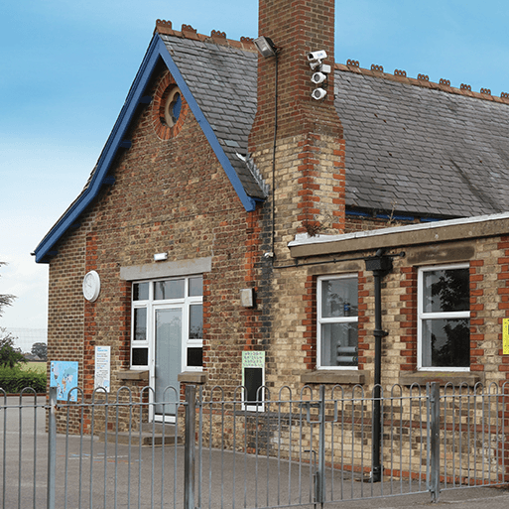  School Days  I can use my knowledge of maps to use satellite images to locate Illogan and my school.  I can make sketch maps of the locality, labelling physical and human features with keys.  I can identify how my school has changed over time using maps and photographs. | 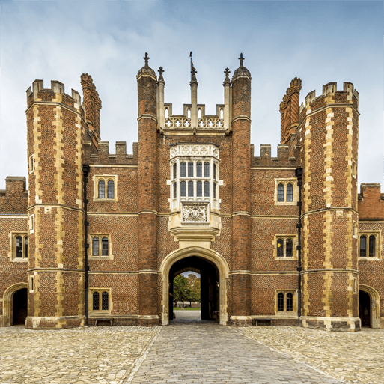  Magnificent Monarchs  Further develop knowledge of the United Kingdom and its four countries and surrounding seas and oceans.  I can use keys and map symbols to locate significant human features.  I can compare how features on maps change over time. | 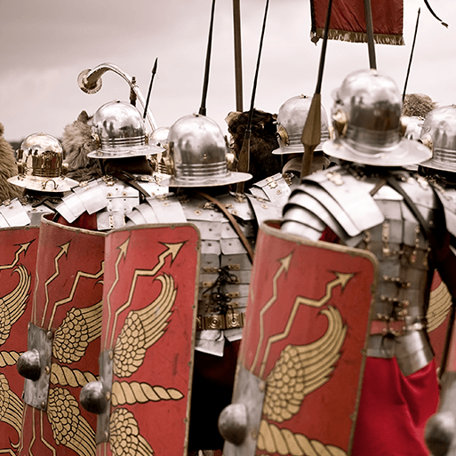  Emperors and Empires  Revisit geographical skills, using maps to observe the growth of the Roman Empire across Europe and the wider world.  I can identify roman features on a modern-day map. | 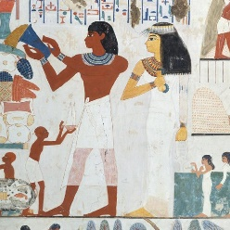  Ancient Civilisations  I can use world maps and atlases to identify the location of Ancient civilisations.  I can use my geographic knowledge to draw conclusions about the climate  I can apply my knowledge of rivers and mountains to explain settlement. | 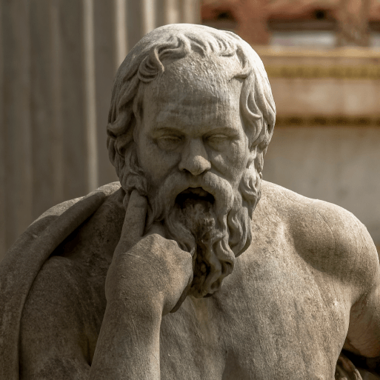  Ground-breaking Greeks  I can use atlases and world maps to locate Greece,  I can use aerial photographs to describe the characteristics and features of the Greek landscape. | 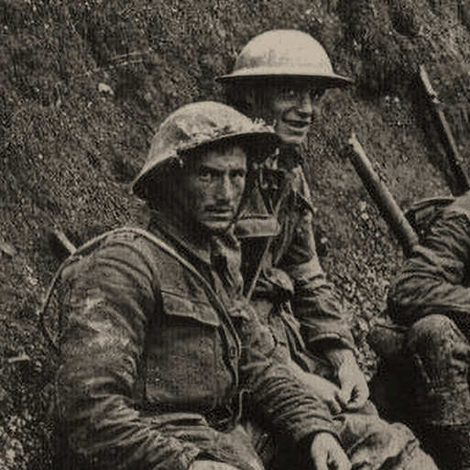  Britain at War  I can use maps of Europe and the world to identify the geographical locations of warring nations in WWI and WWII.  I can compare a modern-day map to one prior to the world wards and identify the changes.

