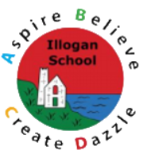

Illogan Primary School
English Policy

At Illogan, we endeavour to develop in the children we teach, a passion and enthusiasm for literacy across all of its formats whilst also allowing our children to express their abilities through both the written word and orally. Here at Illogan, we are enthused by reading and the impact reading for pleasure may have for our pupils as they journey through life. Reading is critical to ensuring independent learning and understanding the world around us, therefore the teaching of reading is given a high priority by all staff.
“Writing is vital for living in the modern world…Why?... It is a means to communicate to an audience the full spectrum of human emotions and intent. Words, if viewed as a commodity, are a powerful exchange of thinking between writer and reader.” (Jane Considine, 2016)
Our objectives in the teaching of English for every child:
- To enable children to speak clearly and audibly; to take account of their listeners and to participate in discussion and debate.
- To encourage, develop and enable children to listen, respond and reflect appropriately to adults and their peers.
- To show and model to children how to adapt their oracy to a wide range of audiences, circumstances and demands to develop eloquent individuals.
- To become fluent, independent readers with a good understanding of texts, through an appropriate focus on word, sentence and text-level knowledge.
- To install a habit of reading widely and often, both for pleasure and information, through contact with substantial and challenging texts which reflect our literacy heritage.
- To develop the powers of imagination, inventiveness and critical awareness.
- To understand a range of text types and genres allowing them to write in a variety of styles and forms appropriate to the situation.
- To acquire a wide vocabulary, an understanding of grammar and knowledge of linguistic conventions for reading, writing and spoken language.
- To produce effective, well-presented work which reflects independent self-monitoring and editing.
- To foster the enjoyment of writing, whilst also recognising its value.
- To raise standards in reading and writing and ensure all children make progress in line with national expectation.

Guidelines for the teaching of English
In Key Stage One and Key Stage Two teachers plan using the 2014 national curriculum framework and additional supporting documents and materials. All aspects of literacy are covered in the lessons including writing, reading, poetry, speaking and listening and drama role play. Teachers are encouraged to build their units of learning through a number of outstanding sources which include: ‘The Write Stuff’ and ‘The Literacy Shed’ in order to inspire, enthuse and engage the children within the writing process. All teachers devise plans including long, medium and weekly plans to inform their learners.
Within our Foundation stage, literacy teaching is incorporated in the structure of the day through an informal approach (Continuous provision). Teachers use the EYFS guidance, Read Write Inc planning and ‘The Write Stuff’ process to structure their learning and planning. At an appropriate stage during the Reception year, children will begin to participate in more formal literacy lessons to prepare them for Year 1.
Writing
The Write Stuff approach across the Whole School
At Illogan, we have adopted ‘The Write Stuff’ approach to our teaching and learning of English to provide clarity to the mechanics of writing for all our learners. Following the method of ‘Sentence Stacking’, the approach places emphasis on sentences being ‘stacked together’ cohesively to support our pupils in delivering short, intensive and purposeful writing moments that inform and enhance the readers experience. Within each genre, the children will focus on the style of the author and the purpose of the text whilst also evaluating and analysing the impact of words and sentences that are appropriate for the studied area of learning. This programme ensures a systematic and incremental approach which mirrors mathematical teaching in the sense that all learners are building their writing knowledge throughout a unit and are therefore able to apply their learnt skills within the context and parameters of the genre of study.
Within each writing lesson, pupils learning is ‘chunked’ into three distinct writing opportunities; initiate, model and enable. The initiate stage engages pupils through a variety of stimuli including: media sources, images, captions, drama and discussion with the aim of ‘drenching’ and immersing the learning environment in language to support pupils the writing process. Following the initiate stage, the lesson moves through to the modelling period. This is where the teacher demonstrates the thoughts and processes of a writer whilst also commentating and articulating the writing choices and discussions that may take place in the heads of writers at this stage. Finally, the enable stage provides the children with the opportunity to showcase what they have learnt during the learning ‘chunk’ and apply this within the parameters of the Three Zones of Writing: The FANTASTICs, The GRAMMARISTICs and the BOOMTASTICs. Each lesson will contain between 2 and 4 learning chunks.
The Three Zones of Writing
The Three Zones of Writing are essential components to support pupils in becoming confident, creative and cultured writers. Through the nine idea lenses known as the FANTASTICs, pupils focus on the intended purpose of the sentence. The GRAMMARISTICs allow pupils to focus on the grammatical elements of writing which focuses on sentence construction, punctuation, and grammar rules. The BOOMTASTICs allow pupils to immerse, capture and create vivid visuals for the reader using poetic devices. Zones of Writing are embedded, revisited, and applied throughout all writing units ensuring cohesion and understanding is developed in context and therefore learners can build connections within their learning.
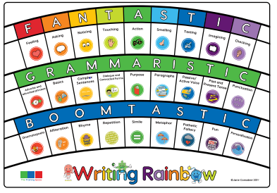
Editing and Drafting Learning
The editing and drafting of written work is given a high profile across the school. Children are encouraged to adopt a critical eye towards their own writing and learning. Day to day work may be edited by pupils, classmates or adults making additions and changes focussing on the content, structure, grammar punctuation and spelling through ‘Pit-stop Plenaries’. ‘Green for growth’ or ‘Dot on the spot’ are recognised by all children as common marking prompts outlined in our marking policy.
Where pupils have edited their work, this is represented with purple pen to clearly show learning moving forwards. Where possible, this will be live and covered through live marking. Teachers are encouraged to use ‘Pit-stop Plenaries’ regularly through lessons to allow learners to review their work.
Poetry
Each half term, the children learn poems linked to their class topics. The children also have the opportunity to create their own poetry based upon these topics. Again, this is delivered through our The Write Stuff scheme of learning.
Working Walls
Working walls are an integral part of English teaching. Each classroom has a working wall allocated for English and this is a used a tool to assist in the teaching of each genre covered. Working walls illustrate the learning journey taken in the build-up to an extended piece of writing. On each working wall, teachers and children build up to the final piece of writing following the below guide:
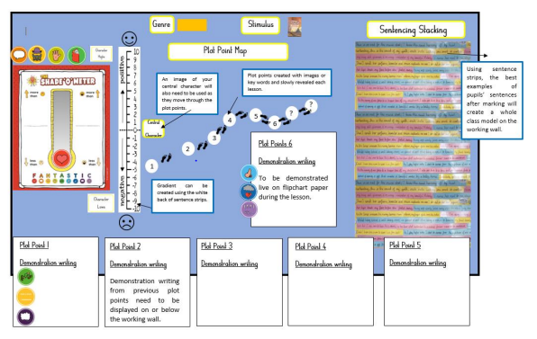Spellings
In KS1 and KS2 the children have spellings to practise and learn in school and at home. Each week, the children will learn a new spelling rule and their weekly spellings fit this rule. Spellings are shared through our Parent-School messaging format Class Dojo on a weekly basis, or in paper form. In addition to weekly spelling rules, the children will learn common exception words. These words don’t fit a spelling rule and therefore are added to the spelling list each week.
Handwriting
The children start learning to form letters through Read Write Inc. lessons in EYFS. They have the opportunity to practise forming letters daily during these lessons. The children also enjoy practising letter formation through continuous provision. Please see the picture below for the Read Write Inc. letter formation rhymes that we teach the children. 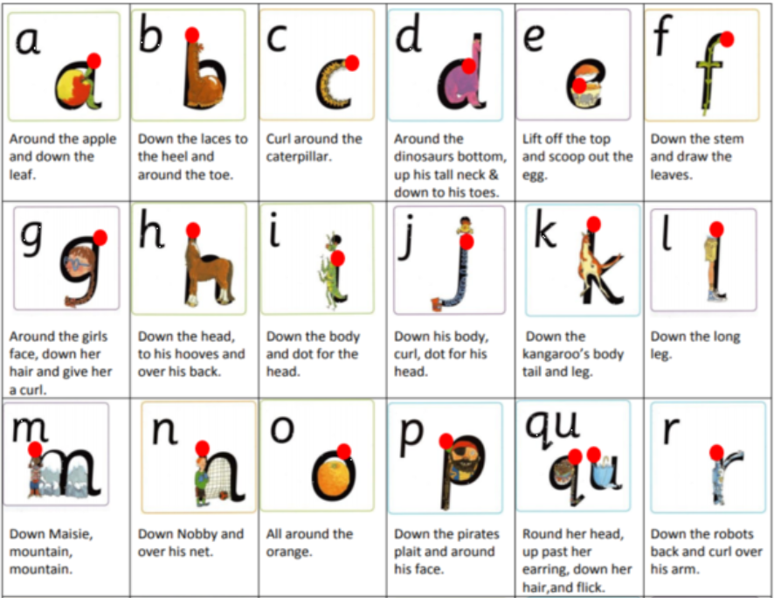
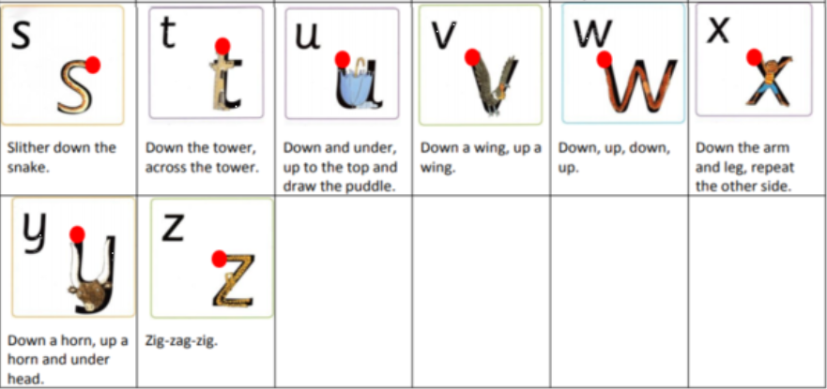
Letterjoin for Handwriting
Following the initial formation learning covered in Foundation stage, the children participate in formal handwriting lessons following ‘Letterjoin’ scheme of learning. Teachers have access to differentiated smart board examples to share and model expectations. Pupils are encouraged to adhere to this scheme of handwriting when required to record writing or learning across the curriculum. In addition, teachers model, create resources and display the Letterjoin font through all of our learning.
Reading
At Illogan we use the VIPERS approach to teach the skill of reading across the school from Year Two. This is delivered through a whole class reading approach where a high quality novel is chosen to study through a half term.
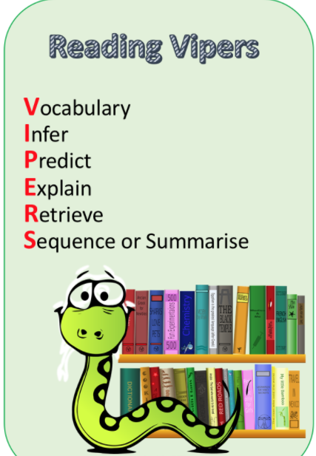
EYFS and KS1
At Illogan School children from EYFS to Year 2 learn to read through Read Write Inc.
The children learn to read by saying the sounds that the letter/letters make. During Read Write Inc, the children practise their reading through exciting and interesting books which are closely matched to their reading ability. This enables the children to gain confidence and progress with their reading. Once children have progressed beyond the RWI Programme they join a KS1 Shared Reading class. Whilst this group ensures children are revisiting RWI sounds daily, the teacher’s main focus is to prepare children for the Accelerated Reader programme they will access upon completion of RWI. The shared reading class allows children to access a wide variety of reading materials; both fiction and non-fiction and opportunities to expand on their comprehension knowledge through formal Guided Reading lessons using our VIPER’s format.
KS2
In KS2, the children build upon their reading and comprehension skills through whole class reading lessons. Each half term the class read a new text. Whilst reading the text, the teachers and children discuss the vocabulary, make predictions, explain what they know and why, through finding answers to questions within the text.
Children off the RWI programme in Key Stage 1 and children within KS2 also use Accelerated Reader alongside whole class reading lessons. During Accelerated Reader lessons, the children have the opportunity to read and then review their understanding and comprehension of a book through taking a quiz about their chosen text. We encourage the children to read a range of fiction and non-fiction texts.

Within the classroom
Each classroom will have the following on display;
- Key vocabulary and phrases from their Write Stuff text.
- Shared writing examples of children’s work.
- Grammatical terminology currently being covered during learning unit.
- Appropriate learning prompts on working wall to enhance and enable the learning environment for all learners.
- Guided reading area to reflect the current whole class novel and novel being covered during our reading for pleasure time at the end of the day. (Within KS1, reading area to display book chosen for that day by class)
Reading Area
Each classroom will have a designated reading area which may include the following:
- Good condition and breadth of fiction and non-fiction books including booms recommended by class teacher and books linked to current learning across the curriculum.
- Story telling props/costumes (where appropriate)
- Accelerated Reader band guidance
In addition to the classroom resources, there is a well-stocked library with levelled reading books available within the Heart space and library.
Assessment in English – Reading
On a daily/weekly basis:
- Books are marked daily using the agreed Illogan marking policy ensuring appropriate and instant feedback is provided where possible, to maximise impact and move learning forwards.
- Note to self sheets to be completed by teachers and staff working within classes to reflect learning taking place and address gaps.
- Assessments to be carried out by RWI Leader to assess progress of children across the scheme to enable swift movement through the scheme for all learners.
- Reading records to be checked and shared with teachers to ensure regular reading at home with parents is taking place and for interventions to be put in to ensure reading is consistent.

On a half-termly/Termly basis:
- Star Reader Quizzes to be taken to identify progress and gaps for upcoming planning/interventions
- Formative assessment to ensure accurate assessment of levels to support teacher assessment (either NFER test or NGRT test)

On an annual basis:
- End of Key Stage assessments are conducted in years 2 and 6;
- Comments recorded in the annual report regarding current achievement and next steps for each child
- Review of learning through Sonar to establish learning progress over the year with final steps recorded for leaders/next class teacher.
Assessment in English – Writing
Daily/weekly/termly basis
- Books are marked daily using the agreed Illogan marking policy ensuring appropriate and instant feedback is provided where possible, to maximise impact and move learning forwards.

- Evidence is provided through independent and teacher-led writing tasks which cover a range of genres through our Write Stuff scheme of learning
- Half-termly assessment for each child is recorded on Sonar
- Details of progress are recorded on planning and Note to Self sheets
- At least two opportunities per half term to allow writing to be implemented through topic focussing on key subject (Geography or History)
- Grammar progression document used to inform teaching and ensure full coverage of areas.
On an annual basis:
- End of Key Stage moderation is made in Years 2 and 6.
- Teachers produce a range of different text types and genres for selected pupils for the moderation of writing
- Moderation to take place with other Crofty MAT schools to evaluate and ensure accurate assessments for each year band.
SEND Pupils
Children with special educational needs may receive additional support through;
- Targets and programmes set in ILPs
- Additional teaching time both in and outside the classroom
- Specialised and adapted resources and lesson material to support appropriate engagement and access to learning to encourage independence
- Additional practice provided by SEND coordinator and outside agencies.
- Where a pupil has a 1:1 adult, staff will record learning outcomes, progress and further development points for the teacher to use within their assessment of the child.
- Next steps for children are recorded within books using ‘Green for growth’ and positive learning outcomes are once again recorded in ‘Tickled Pink’ to celebrate where learning has been moved forwards.

