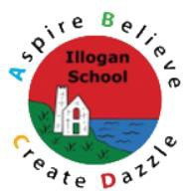
Design Technology Overview

EYFS Projects | Year 1 | Year 2 | Year 3 | Year 4 | Year 5 | Year 6
Autumn
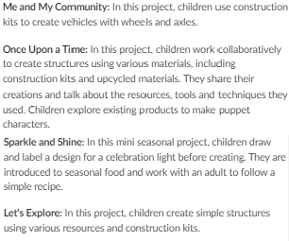  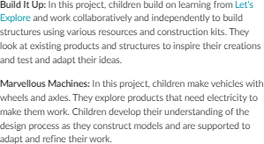 | 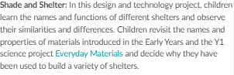  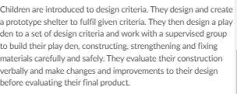 | 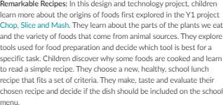 | 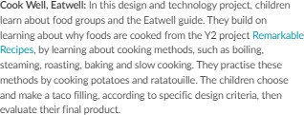 | 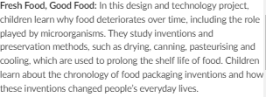  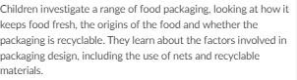  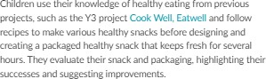 | 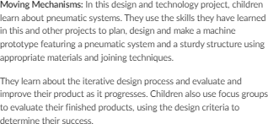 | 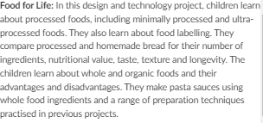  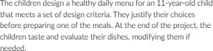
 | 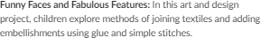 |  |  | 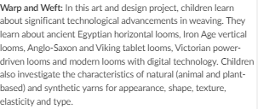
Spring
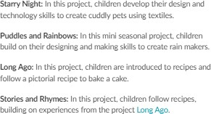  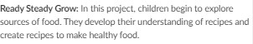 | 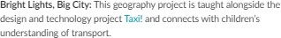 | 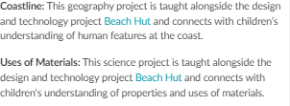 | 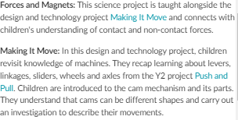  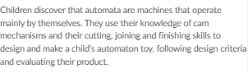 | 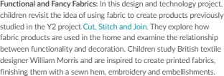 | 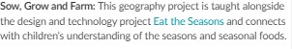 | 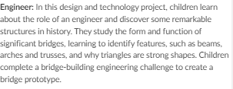
 | 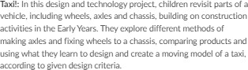 | 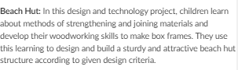 |  |  | 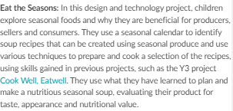
Summer
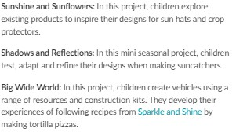 | 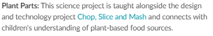  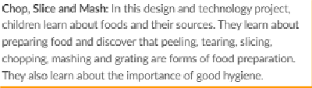 | 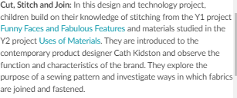  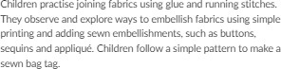 | 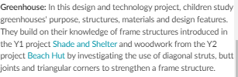  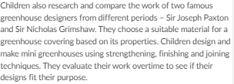 | 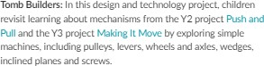  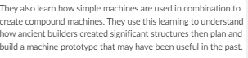 | 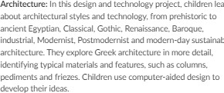  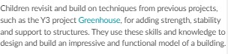

Splash!: In Lhis. mirii seasonal project. children consolidate Lheir e:,qx!rience and understanding of following recipes independently to make lee lollies.  Animal Safari: In lhi5 project children develop their learning from tho Build It Up proje<l and work oollaooratively 10 make aoimal shelu,rs. Tt-.,y devclop joining t.e<hoiqu.,s introduceo in Puppets and Pop Ups and explore foldiog ar<l curling paper to creau, animal masks.  On the Beach: ln this seasonal project. children develop Lheir kno1Medge of 'VChicles from Marvellous Machines and design and make seafaring vehides. | The children use preparatory techniques Lo make a healthy salad before tasting and evaluating their dish. They also design a supermarket s.andwic.h. choosing and preparing the ingredierits to make them heallhy. tasty and easy to eat on the go. At Lhe end of the project. the children taste and evaluate their products..  Animal Parts: This science project is taught alongside the design and technology project Chop. Slice and Mash and coonects. 'MLh children's understanding of animal-basOO foocl sources. | Pu!.h and Pull: In this design and tecl1nology project children learn ll'lat machines make work easier and define Lhe terms machine.. component .and mechanism. They explore sliders. levers. and linkages. and make moving model5 of a!I three LJtSing joining and finishing techniques.. Children apply theJr learni:ng to desig_n and make greetings cards with moving parts that us.e Lhes.e mechanisms.

