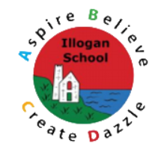
Illogan Whole School Art Progression

Below are the knowledge and skills that will be developed in specific aspects of art during a pupil’s time at Illogan.
There are 13 key aspects that our Art curriculum covers:
- Human form
- Creation
- Generation of ideas
- Evaluation
- Malleable materials
- Paper and fabric
- Paint
- Printing
- Pencil, ink, charcoal, and pen
- Natural art
- Landscapes
- Compare and contrast
- Significant people, artwork and movements
