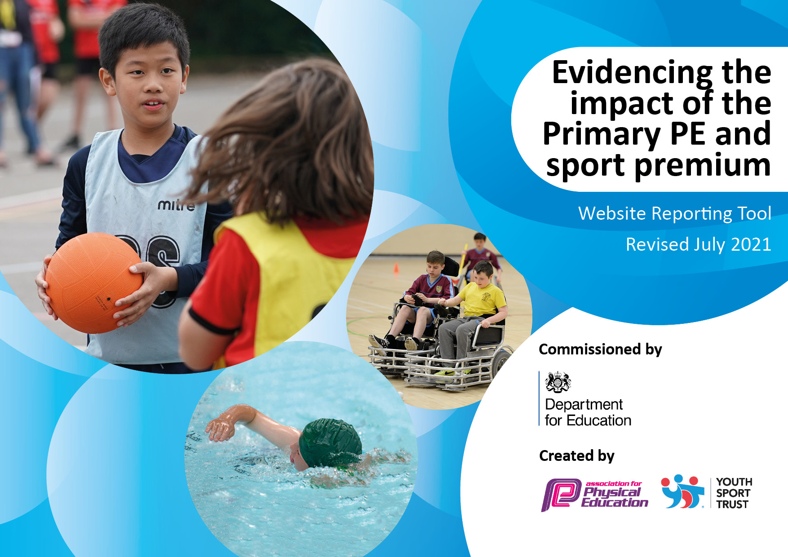
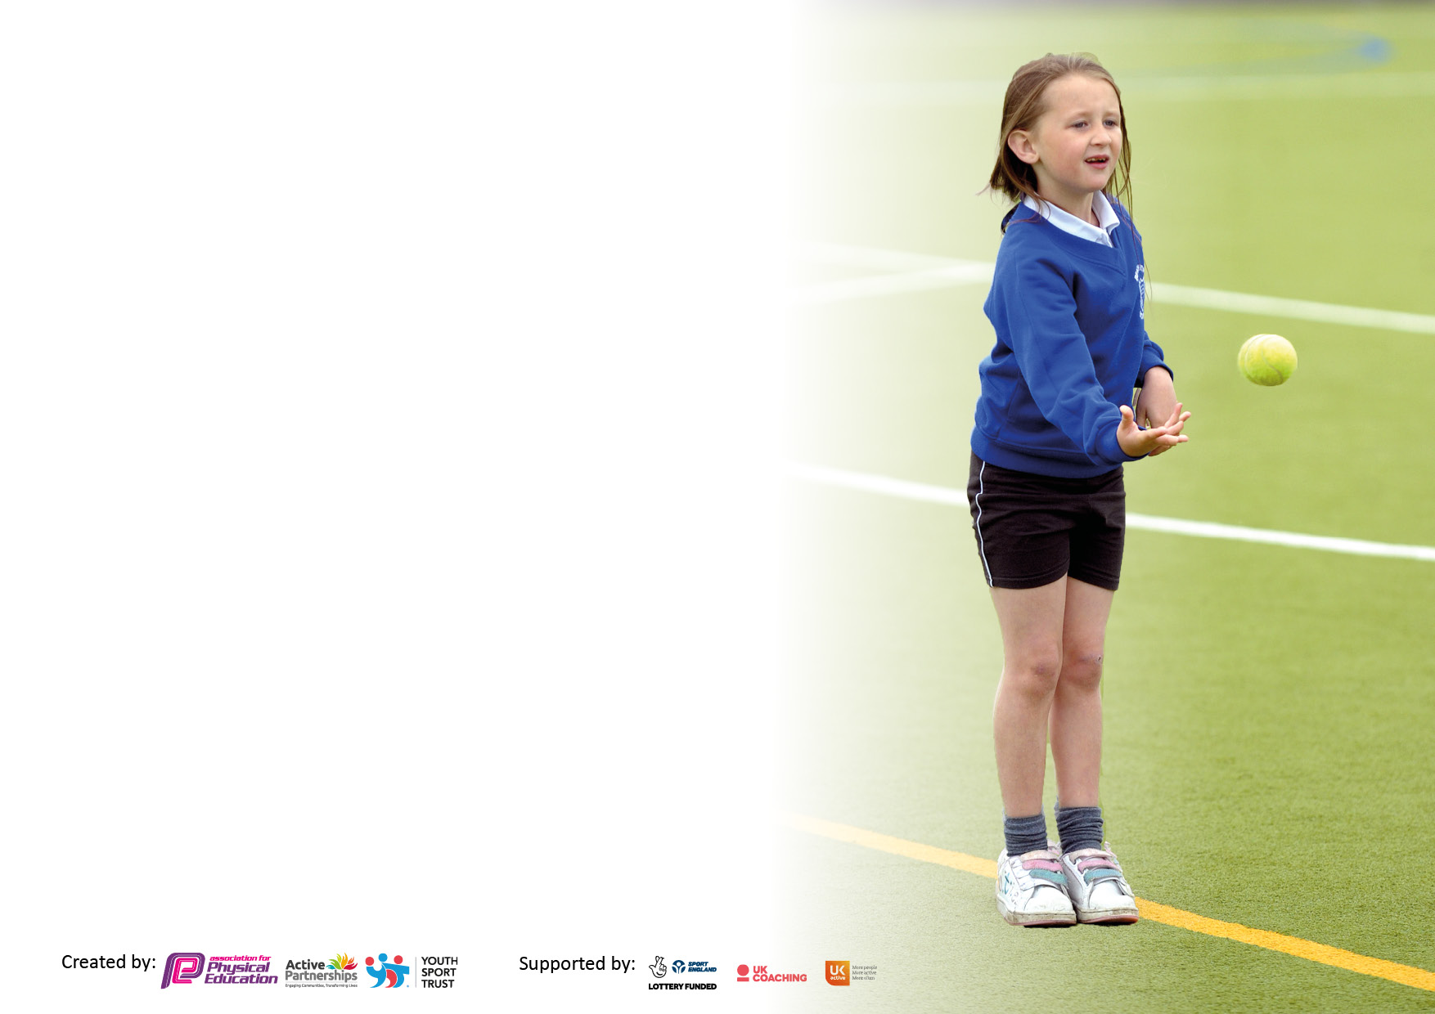

It is important that your grant is used effectively and based on school need. The Education Inspection Framework makes clear there will be a focus on ‘whether leaders and those responsible for governors all understand their respective roles and perform these in a way that enhances the effectiveness of the school’.

Under the Quality of Education Ofsted inspectors consider:
Intent - Curriculum design, coverage and appropriateness
Implementation - Curriculum delivery, Teaching (pedagogy) and Assessment
Impact - Attainment and progress

To assist schools with common transferable language this template has been developed to utilise the same three headings which should make your plans easily transferable between working documents.

Schools must use the funding to make additional and sustainable improvements to the quality of Physical Education, School Sport and Physical Activity (PESSPA) they offer. This means that you should use the Primary PE and sport premium to:

- Develop or add to the PESSPA activities that your school already offer
- Build capacity and capability within the school to ensure that improvements made now will benefit pupils joining the school in future years
- The Primary PE and sport premium should not be used to fund capital spend projects; the school’s budget should fund these.

Pleasevisitgov.ukfortherevisedDfEguidanceincludingthe5keyindicatorsacrosswhichschoolsshoulddemonstrate animprovement.Thisdocumentwillhelpyoutoreviewyourprovisionandtoreportyourspend.DfEencouragesschools to use this template as an effective way of meeting the reporting requirements of the Primary PE and sport premium.

We recommend you start by reflecting on the impact of current provision and reviewing the previous spend.

Schools are required to publish details of how they spend this funding, including any under-spend from 2019/2020, as well as on the impact it has on pupils’ PE and sport participation and attainment. All funding must be spent by 31st July 2022.

We recommend regularly updating the table and publishing it on your website throughout the year. This evidences your ongoing self-evaluation of how you are using the funding to secure maximum, sustainable impact. Final copy must be posted on your website by the end of the academic year and no later than the 31st July 2021. To see an example of how to complete the table please click HERE.
Created by: Supported by:

Details with regard to funding
Please complete the table below.

Total amount carried over from 2019/20 | £0
Total amount allocated for 2020/21 | £ 17,600
How much (if any) do you intend to carry over from this total fund into 2021/22? | £0
Total amount allocated for 2022/23 | £17,780
Total amount of funding for 2022/23. To be spent and reported on by 31st July 2023. | £17,780
Swimming Data
Please report on your Swimming Data below.

Meeting national curriculum requirements for swimming and water safety.  N.B. Complete this section to your best ability. For example you might have practised safe self-rescue techniques on dry land which you can then transfer to the pool when school swimming restarts.  Due to exceptional circumstances priority should be given to ensuring that pupils can perform safe self rescue even if they do not fully meet the first two requirements of the NC programme of study | 65.63%
What percentage of your current Year 6 cohort swim competently, confidently and proficiently over a distance of at least 25 metres?  N.B. Even though your pupils may swim in another year please report on their attainment on leaving primary school at the end of the summer term 2021.  Please see note above | 65.63%
What percentage of your current Year 6 cohort use a range of strokes effectively [for example, front crawl, backstroke and breaststroke]?  Please see note above | 65.63%
What percentage of your current Year 6 cohort perform safe self-rescue in different water-based situations? | 56.5%
Schools can choose to use the Primary PE and sport premium to provide additional provision for swimming but this must be for activity over and above the national curriculum requirements. Have you used it in this way? | Yes/No

Action Plan and Budget Tracking
Capture your intended annual spend against the 5 key indicators. Clarify the success criteria and evidence of impact that you intend to measure to evaluate for pupils today and for the future.

Academic Year: 2022/23 | Total fund allocated: | Date Updated:
Key indicator 1: The engagement of all pupils in regular physical activity – Chief Medical Officers guidelines recommend that primary school pupils undertake at least 30 minutes of physical activity a day in school |  |  |  | Percentage of total allocation:
 |  |  |  | 29,39% - £5,226.25
Intent | Implementation |  | Impact
Your school focus should be clear what you want the pupils to know and be able to do and about  what they need to learn and to  consolidate through practice: | Make sure your actions to achieve are linked to your intentions: | Funding allocated: | Evidence of impact: what do pupils now know and what can they now do? What has changed?: | Sustainability and suggested next steps:
The intent is to provide opportunities for all of our children to develop the fundamental physical skills which will enable them to develop and progress throughout their time and Illogan and use these skills within daily movement, competitions, games and other sports. | RealPE annual membership for teaching / curriculum  Use of MOKI watches to encourage increased physical activity, tracking of this and consideration of impact  Football posts and nets to enable children to participate in football throughout the school day  Renovation of sand pit area to ensure additional outside play opportunities | £695  £831.25  £1000  £2700 | RealPE curriculum is fit for purpose and has a focus on physical literacy and developing the fundamental skills and traits that we, as a staff, identified as most beneficial to the children in our care (social, emotional, cognitive etc)  Able to monitor activity levels in alignment with ensuring children are active for 30-60 minutes a day.  Enabled children to play and use the equipment for learning and playtime purposes, developing activity levels throughout the school day.  Children in EYFS have a strong start to their physical development through sand play and fine / gross motor skills. | Staff confidence and skills will be monitored regularly through staff self-audits and through informal coaching sessions and more formal PE lesson observations.  Batteries to be bought and further use on implementation of Moki watches from September 2023.  Continue to expand this and opportunities for other sports next year.
Key indicator 2: The profile of PESSPA being raised across the school as a tool for whole school improvement |  |  |  | Percentage of total allocation:
 |  |  |  | 5.46% - £970
Intent | Implementation |  | Impact
Your school focus should be clear what you want the pupils to know and be able to do and about  what they need to learn and to  consolidate through practice: | Make sure your actions to achieve are linked to your intentions: | Funding allocated: | Evidence of impact: what do pupils now know and what can they now do? What has changed?: | Sustainability and suggested next steps:
Development of squads (school teams) to enable inter-school competitions.  Give children opportunities to develop an understanding of a healthy life-style, making connections with physical and emotional health. | Purchase of sweatbands for each child to create culture of belonging to squad | £970 | Children and staff are now all part of a ‘squad’ (house team) where there is weekly competition of points system. | For all children to receive their colour squad band at the start of academic year (September 2023) and launch team challenges and prizes to raise profile.

Key indicator 3: Increased confidence, knowledge and skills of all staff in teaching PE and sport |  |  |  | Percentage of total allocation:
 |  |  |  | 14.67% - £2,608.20
Intent | Implementation |  | Impact
Your school focus should be clear | Make sure your actions to | Funding | Evidence of impact: what do | Sustainability and suggested
what you want the pupils to know | achieve are linked to your | allocated: | pupils now know and what | next steps:
and be able to do and about | intentions: |  | can they now do? What has
what they need to learn and to |  |  | changed?:
consolidate through practice:
PE lead to attend realPE leadership training in order to be aware of the scheme to support staff in teaching and application of it within PE lessons.  Teachers to use the realPE online platform to support them with lesson structure and teaching practice.  British Cycling Ride Leader L1 qualification – to facilitate Y6 cycling activities. | PE subject leader training (REAL PE)  Interactive whiteboard screen for hall  Complete British Cycling Ride Leaders qualification | £245  £2,163.20  £200 | More confidence for PE lead in leading and delivering subject knowledge and teaching practice expectations to teaching staff.  Allows teachers easy access of realPE platform for sharing of skills being modelled during lessons.  This qualification has allowed children in Y6 to access local trails to ride as a group. | Subject lead to continue monitoring the teaching of PE and support teaching staff where appropriate with leadership skills.  Monitor that teachers are using the platform and can access all aspects of it with ease.  Create club for next year and develop engagement for a wide variety of children.
Key indicator 4: Broader experience of a range of sports and activities offered to all pupils |  |  |  | Percentage of total allocation:
 |  |  |  | 15.98% - £2,840.90
Intent | Implementation |  | Impact
Your school focus should be clear | Make sure your actions to | Funding | Evidence of impact: what do | Sustainability and suggested
what you want the pupils to know | achieve are linked to your | allocated: | pupils now know and what | next steps:
and be able to do and about | intentions: |  | can they now do? What has
what they need to learn and to |  |  | changed?:
consolidate through practice:
Our children at Illogan should be encouraged and be provided with opportunities for a greater range of after school and professionally delivered sports. | Gillian Sadler – Dance and Yoga Teacher  Basketball hoops  Tension balls  Marking of football pitch  Football goals  Football nets  Cornish Pirates for Years 5 and 6  Tennis for Year 1  Surf day for year 6  Teachers and TA provide a range of afterschool clubs. • Bike Club • Netball • Girl’s football • Boys football • Multi skills • Dance • Yoga | £652.50  £313.52  £30  £160  £89.95  £69.95  Awaiting invoice approx. £600  £270  £655 | All year groups had the opportunity to attend these sessions during lunch times.  All children have access to these within PE lessons and at lunchtimes.  Big push on promoting football within the school for both boys and girls – these recourses supported this.  Range of alternative opportunities for our children in alignment with Illogan’s ‘PE Heart strings’  Children have the opportunity to access a wide variety of sporting clubs and opportunities. | Pupil voice children on range of clubs and consider suggestions for year 23/24.  Continue to use and get children engaged next year – think about basketball club.  Continue efforts with this next year.  Ensure this happens again next year and explore further / alternative opportunities.  Continue to ensure there are a variety of sporting clubs and opportunities each term for every child.

Key indicator 5: Increased participation in competitive sport |  |  |  | Percentage of total allocation:
 |  |  |  | 6.66% - £1,184.33
Intent | Implementation |  | Impact
Your school focus should be clear | Make sure your actions to | Funding | Evidence of impact: what do | Sustainability and suggested
what you want the pupils to know | achieve are linked to your | allocated: | pupils now know and what | next steps:
and be able to do and about | intentions: |  | can they now do? What has
what they need to learn and to |  |  | changed?:
consolidate through practice:
Our children at Illogan should have the opportunity to engage, participate and be exposed to a variety of different sports and sporting events across each school year.  Children should be able to feel proud to represent our school and attend events in smart uniform. | Transportation to competitive MAT events  Crofty PE membership and attendance at all events  New sports kits for attendance at competitions  Sports day stickers and medals | £100  £700  £284.33  Approx. £100 | Enables pupils to participate when no MAT mini buses were available.  Illogan has had 100% attendance at all MAT sporting opportunities this year enabling a variety of children from all year groups to participate in sporting events and competitions within a variety of different sports. | Organise lift sharing across schools with MAT mini buses.  Continue level of participation in year 23/24 and ensure different children are chosen for events to allow for opportunities for a wider variety of children across the school.  Use again next year. Potentially invest in getting school logo added.  Use again next year.

Total spent: £12,830 – 72.16%
Total to be carried over into 23/24: £4950

Signed off by
Head Teacher: | L. Wandless
Date: | 29.7.23
Subject Leader: | E. Rapsey
Date: | 30.7.23
Governor:
Date:

